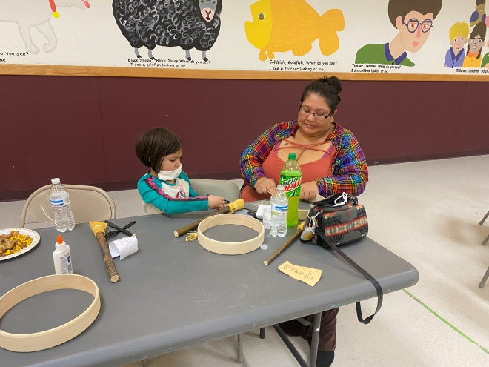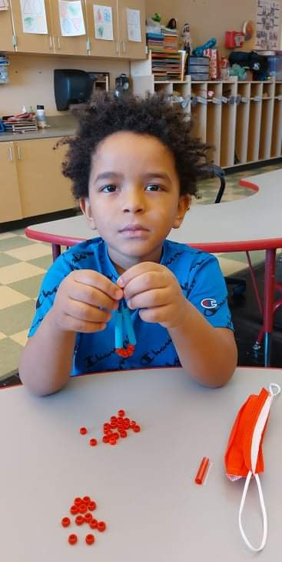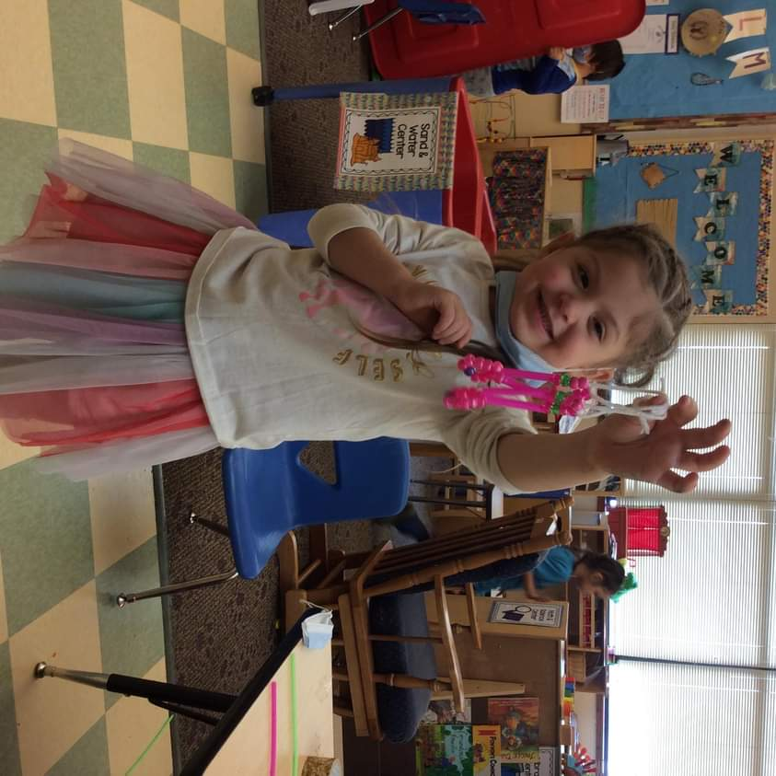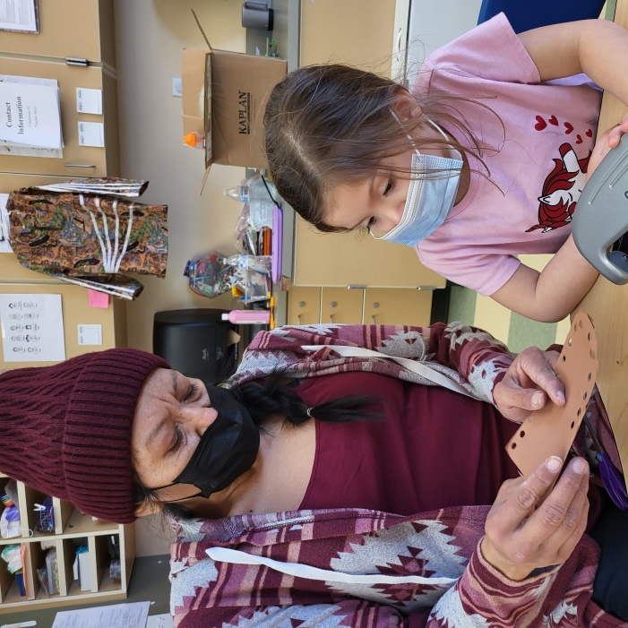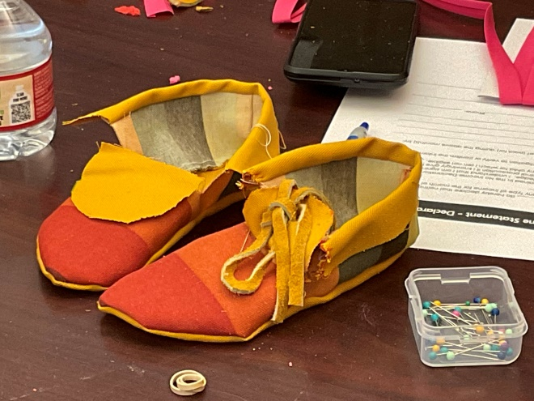

Contents
Head Start Mission Statement 3
Center Contact Information: 3
Staff/Volunteer Background Checks 3
Hours of Operation 5
Service Delivery 7
Head Start Center Based Program 7
Early Head Start Home-Based Program (Omak only) 7
Early Head Start Center-Based Program (Omak only) 7
Early Head Start/Head Start Child Care Program (Keller only) 7
Early Head Start Prenatal Program (Omak, Keller, Inchelium) 8
Annual Program Closures 9
Emergency Closures 9
Childcare Payment Information 10
Family Rights 10
Education Services 11
Our Part.... 11
Your part... 12
45 Day Requirements 13
Screening Tools 13
Assessment Tools 13
Curriculum 13
The Creative Curriculum® for Preschool, 6th Edition 13
Creative Curriculum® for Infants, Toddlers & Twos 14
Second Step 14
Second Step Child Protection Unit 14
Since Time Immemorial Early Learning Curriculum 15
Partners for a Healthy Baby 15
CLASS Observations 15
Home Visits 15
Parent Teacher Conferences 16
Child Guidance and Behavior Management 16
Attendance 17
Disabilities 18
Transportation 19
Health Services 20
Screening and Ongoing Health Care 20
Allergies 20
Immunizations 20
Nutrition: 21
Medical and Dietary Considerations: 22
Oral Hygiene: 23
Illness 23
Medication Administration 24
Lice 24
Mental Health: 25
Handling Separation 25
Safety 28
Handwashing 28
Child Release 28
Medical Emergency 28
Family Partnerships 29
Family Support Services 29
Family and Child Outcomes 29
Family Involvement 30
Volunteering 30
Policy Council Member 31
Health Services Advisory Committee 31
Parent Committee 31
Children’s Activities 31
Parent Activities 32
Important Policies 33
Civil Rights 33
Affirmative Action and Non-Discrimination 34
Confidentiality 34
Notice of Privacy Practice 34
Student Education Records 34
Custody Orders and/or Court Related Requests 37
Program Involvement of Registered Sex Offenders 37
Intoxicated Caretaker Policy 37
Reporting of Suspected Child Abuse and Neglect 38
Tobacco Use 39
Grievance 39
GRIEVANCE FORM 42

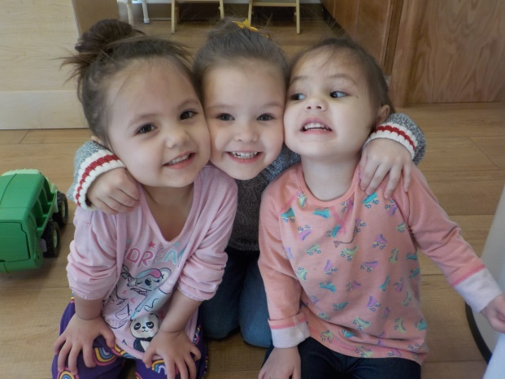
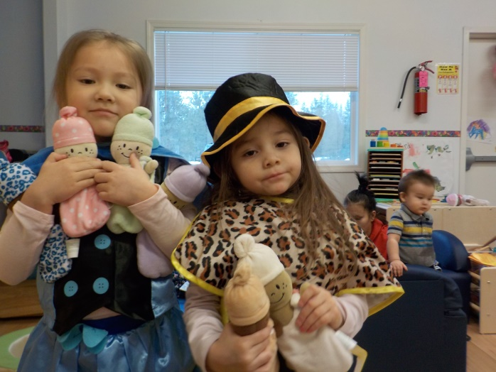
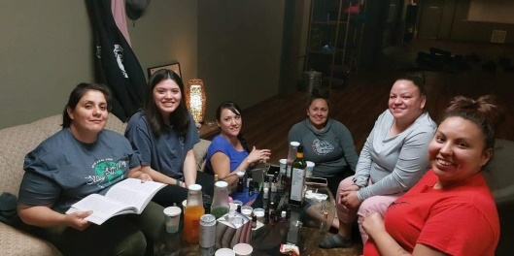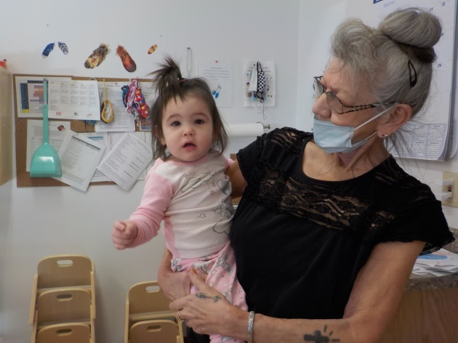

Head Start Mission Statement
The Colville Tribes Head Start is a community program involved in improving the quality of life for children and families. Head Start advocates through partnerships and individualized educational opportunities that will strengthen and preserve the child, their family and community, while maintaining respect to tradition, culture, and heritage. (2015)
Center Contact Information:

Inchelium
Site Supervisor | (509) 722-7051
Family Support Specialist | (509) 722-7025
Birth to 3 Family Support Specialists | (509) 722-7087
Teachers | (509) 722-7027
Head Start Specialists | (509) 722-7029
Nutrition Staff | (509) 722-7054
Reception | (509) 722-7054
Fax | (509) 722-7053

Keller
Site Supervisor | (509) 634-7318
Family Support Specialist | (509) 634-7318
Teachers/Head Start Specialists | (509) 634-7317
Child Care Center | (509) 634-7319
Nutrition Staff | (509) 634-7316
Reception | (509) 634-7318
Fax | (509) 634-7328

Nespelem
Site Supervisor | (509) 634-2299
Family Support Specialists | (509) 634-2278  (509) 634-2279
Birth to 3 Family Support Specialists | (509 634-2403
Teachers/Head Start Specialists | (509) 634-2404
Nutrition Staff | (509) 634-2773
Reception | (509) 634-2298
Fax | (509) 634-2788

Omak
Site Supervisor | (509) 422-7707
Family Support Specialist | (509) 422-7444
Early Head Start Family Support Specialists | (509) 422-7780
Head Start Teaching Staff | (509) 422-7708
Early Head Start Specialists | (509) 422-7792
Nutrition Staff | (509) 422-7709
Reception | (509) 422-7707
Fax | (509) 422-7445

Administrative Staff
Program Manager | O (509) 634-2760  C (509) 634-1340
Assistant Program Manager | O (509) 422-7780  C (509) 634-6091
Head Start Senior Administrative Assistant | O (509) 634-2298  C (509) 634-6056
Early Head Start Senior Administrative Assistant | Office (509) 422-7780
ERSEA Specialist | (509) 634-2320
Health/Disabilities Specialist | (509) 634-2378
Education Specialist | (509) 634-2324
Mental Health Professional | O (509) 634-2787 C (509) 634-1778
Main Office Reception | (509) 634-2298  F (509) 634-2788

Staff/Volunteer Background Checks
All Head Start employees, volunteers, contractors, individuals on a contract, whose activities involve contact with and/or direct services to children and families or anyone who could have unsupervised access to children and families must complete the following to continue working/volunteering:
- An interview
- Sex Offender Registry Check
- Reference verification
- State, Tribal, or FBI Criminal History Records, including fingerprint check
- Child Abuse and Neglect State Registry Check
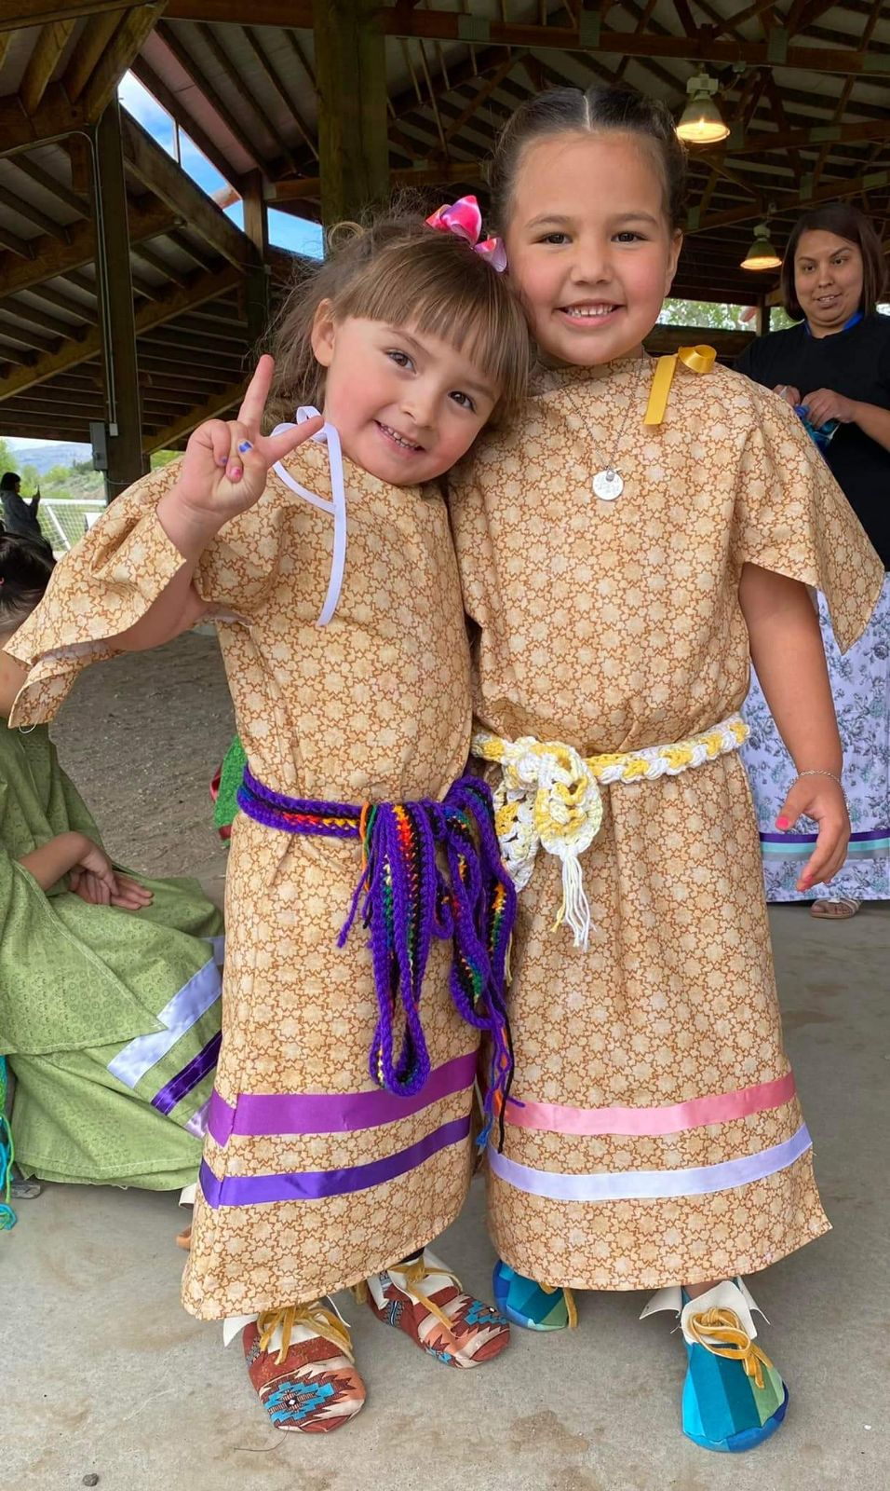
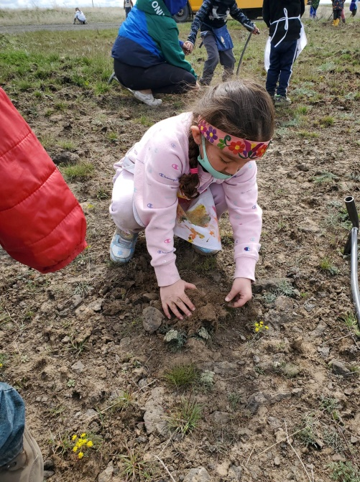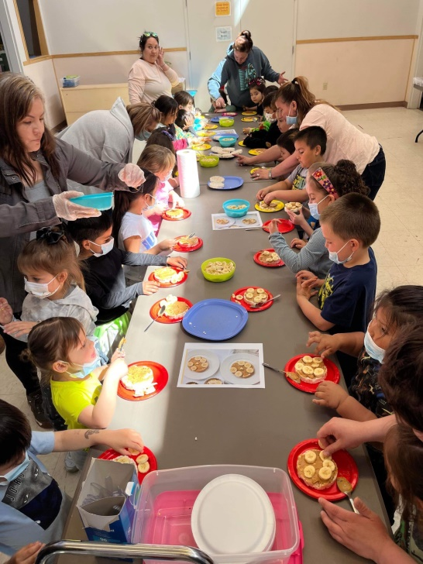

Hours of Operation
Inchelium Head Start | Monday-Thursday 9am-1pm | 128 days per year
Inchelium Early Head Start Prenatal Program | Variable | 1 hour per month
Inchelium Birth to Three Services | Variable | Varies
Keller Head Start | Monday-Thursday 9am-3pm | 1000 annual hours
Keller Early Head Start- Center Based Program | Monday-Thursday 8am-4pm | 1380 annual hours
Keller Childcare | Monday-Friday 6:45am-5pm | Varies
Keller Early Head Start Prenatal Program | Variable | 1 hour per month
Nespelem Head Start | Monday-Thursday 9am-3pm, one Family Engagement Friday each Month | 1000 annual hours
Nespelem Birth to Three Services | Variable | Varies
Omak Head Start | Monday-Thursday 9am-1pm | 128 days
Omak Early Head Start- Center Based Program | TBD | 1380 annual hours
Omak Early Head Start- Home Based Program | Variable | 1 ½ hours per week/46 weeks
Omak Early Head Start Prenatal Program | Variable | 1 hour per month

Service Delivery

Head Start Center Based Program
Head Start is a comprehensive preschool program for low-income three and four year old children. Head Start is unique in its comprehensive approach in striving to meet the needs of children and families. The Head Start Program works with children and their parents to ensure that children gain the skills needed to succeed in school both academically and socially. The Head Start Program targets the entire family and the services include classroom instruction, health and development screenings, family engagement and goal setting. Every child can succeed and together we’re supporting children, families, and communities. The Head Start Center Based Program offers full-day services in Nespelem and Keller, and half-day services in Omak and Inchelium.

Early Head Start Home-Based Program (Omak only)
The Early Head Start Home-Based Program is a child development program serving children birth to age three. The program is delivered in the child’s primary learning environment, their home. The Early Head Start program recognizes that parents are a child’s first teacher and therefore Home Visitors come to the home to provide support to the child and their family through weekly 90-minute home visits, providing learning activities promoting development in all areas. The Home Visitor and the parent work as a team to identify the child’s strengths and needs. The Home Visitor will share their knowledge of child development and provide training to parents as they begin to set individual and family goals. Socializations are held twice a month in the home-based program to provide an opportunity for children to engage and interact socially with other children.

Early Head Start Center-Based Program (Omak only)
The Early Head Start Center-Based program provides children ages 6 weeks-3 years with classroom experiences planned by qualified staff that promotes developmental growth in all areas. Individualized planning ensures that the specific needs of each child are met in a safe, nurturing learning environment. Teachers and parents will meet four times per year to set and update goals for their child. Children enrolled in the center-based program will attend class Monday - Thursday, times to be determined.

Early Head Start/Head Start Child Care Program (Keller only)
The Keller Child Care Program provides services to children birth to five years of age. The Keller Child Care Center provides a warm and nurturing environment where children feel safe. The Child Care program offers various activities that are specifically designed to encourage each child’s growth. Through cooperative play and creative activities, the children move towards reaching their social, emotional, and physical developmental milestones. The Keller Child Care program also provides comprehensive developmental and continuous services to low-income infants, toddlers, children and their families by providing strong relationship-based experiences that work towards preparing children for the transition into Head Start. The Keller Child Care Center strives to meet the needs of the Keller community and working families by offering full-day and full-year services.

Early Head Start Prenatal Program (Omak, Keller, Inchelium)
The Early Head Start Prenatal program offers services to pregnant women and their families by providing support and resources during their pregnancy in Omak, Keller, and Inchelium. The services are provided to the pregnant mother in the privacy of their home, with 1 visit per month. A healthy pregnancy has a direct influence on the health and development of a newborn child. The Early Head Start Prenatal program strives to have the greatest impact on participating pregnant women by offering supportive services as early in life as possible. The Early Head Start Prenatal program provides prenatal information through home visits on the following subjects:
- Fetal development, including the risks from substance use
- Labor and delivery
- Postpartum recovery, including information on maternal depression
- The benefits of breastfeeding, as well as other subjects relevant to pregnancy
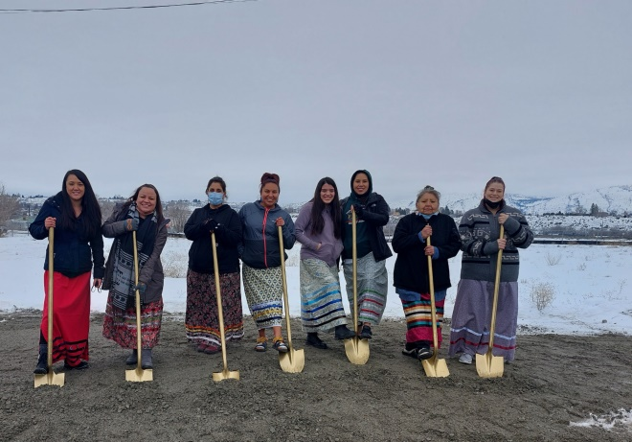
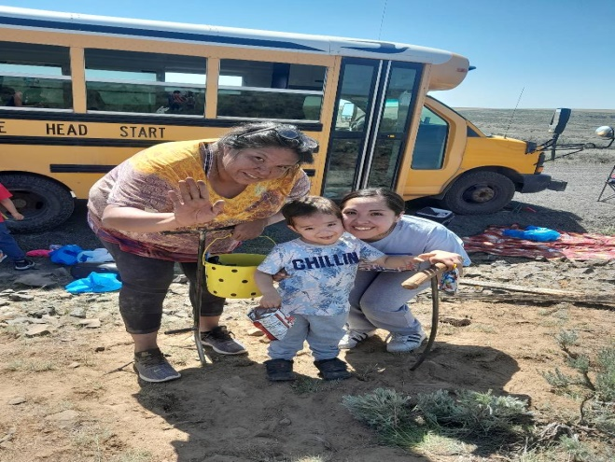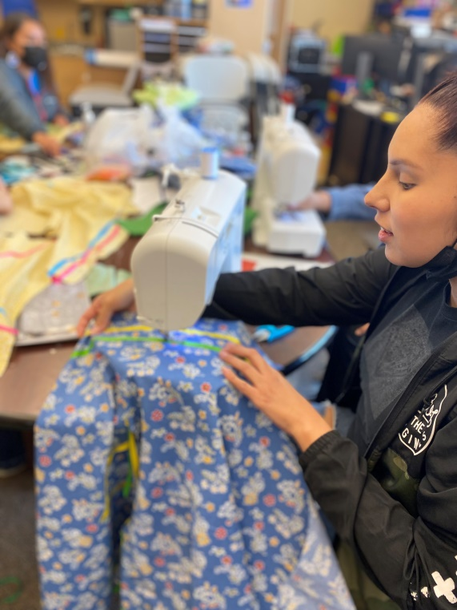

Annual Program Closures

Holidays (All Facilities Closed)
New Year’s Day | January 1
Martin Luther King Day | 3rd Monday in January
President’s Day | 3rd Monday in February
Memorial Day | Last Monday in May
Juneteenth | June 19
CTCR Executive Order | Observed July 3
Independence Day | July 4
Labor Day | 1st Monday in September
Native American Day | 4th Thursday in September
Indigenous People’s Day | 2nd Monday in October
Veteran’s Day | November 11
Thanksgiving | 4th Thursday and Friday in November
Christmas | Workday before and December 25th
Floating Holiday 1 | 3rd Friday in March
Floating Holiday 2 and 3 | Thursday and Friday of 1st Full Week of April

Annual Breaks and Teacher Training (All Facilities Closed)
Christmas Break | December 24th to January 1st
All Staff Professional Development | 3rd Friday of January
Spring Break | 1st Full week of April
All Staff Professional Development | 3rd Friday of April
Annual All Staff Training | 3rd and 4th Full Weeks of August
All Staff Professional Development | 3rd Friday of October

Emergency Closures
Each Head Start center will establish procedures for canceling class in an emergency and assign responsibility for notifying children’s parents or caregivers, and for notifying the Site Supervisor and Head Start Director. In general classrooms or facilities are closed for the following reasons:
- No Water/Electricity
- Shortage of Staff
- Unsafe/Unhealthy conditions i.e. (hazardous weather conditions, no electricity, outbreak of disease or illness)
- Administrative leave closures related to health/safety.
Staff will notify families as soon as possible if a classroom or site needs to be closed.
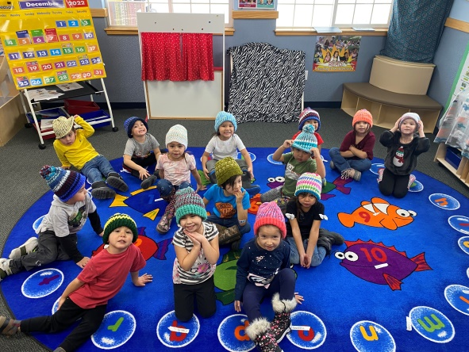

Childcare Payment Information
Licensed Center Base Rate (Daily) effective 7/1/2023
 | Infant | Toddler | Preschool | School-Age
 | Birth-11 Months | 12-29 Months | 30 Months- 6 Years (No School Attendance | 5-12 Years
Full-Day | $62.05 | $56.14 | $53.18 | $53.36
Half-Day | $31.03 | $28.07 | $26.59 | $26.68
School Age Care is limited to those who have just finished Head Start programming and possible exceptions for siblings who attend EHS or HS, Keller District provides services to School Age children at Boys and Girls Club, which is better suited to school aged children.

Family Rights

As a Head Start Family, I have the right to:
- Always be treated with dignity and respect;
- Take part in major policy decisions affecting the planning and operation of the program;
- Be able to learn about the operation of the program, including the budget and level of education and experience required to fill various staff positions;
- Take part in planning and carrying out programs designed to increase my skills in areas of possible employment;
- Help develop adult programs that will improve daily living for me and my family;
- Be informed about all community resources concerned with health, education and the improvement of family life;
- Be welcomed in the classroom; (The program reserves the right to exclude families from the classroom during times of communicable disease outbreaks, epidemics, and pandemics when advised by local, tribal, county, state, and/or federal agency)
- Expect guidance for my child from Head Start teachers and staff to further his/her total individual development;
- Be informed regularly about my child's progress in Head Start; and
- Choose whether or not I participate without fear of endangering my child's right to be in the program.
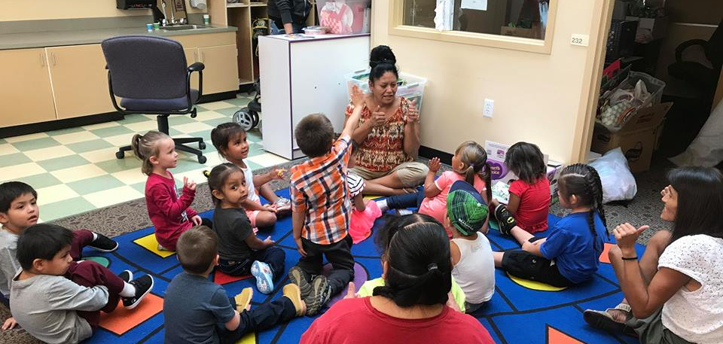

Education Services

Our Part....

- Provide coordinated service that aligns with the Local Education Agency.
- Provide an environment that stimulates each child's curiosity and learning.
- Encourage each child to develop his/her unique pattern of interests, talents, and skills.
- Help children learn through peer interaction and place based natural learning materials.
- Use play to achieve children’s educational goals.
- Obtain parent authorization for all screening completed on children.
- Assist the whole family with school readiness and transition into Kindergarten.
- The focus of Individual goals will be based on needs in the following areas:
  - Language Development: Listening, understanding, speaking, and communicating.
  - Literacy: Phonological awareness (the sounds of words), book knowledge, appreciation of books, print awareness, pre-reading concepts, early writing, and alphabet knowledge.
  - Mathematics: Geometry, spatial sense, patterns, measurements.
  - Science: Scientific skills, methods, and knowledge.
  - Creative Arts: Music, art, movement, and dramatic play.
  - Social and Emotional: Self-concept, self-control, cooperation, social relationships, knowledge of families and communities.
  - Approaches to Learning: Initiative, curiosity, engagement, persistence, reasoning and problem solving. Research shows children learn through play.
  - Physical Health and Development: Fine and gross motor skills, health status and health practices.
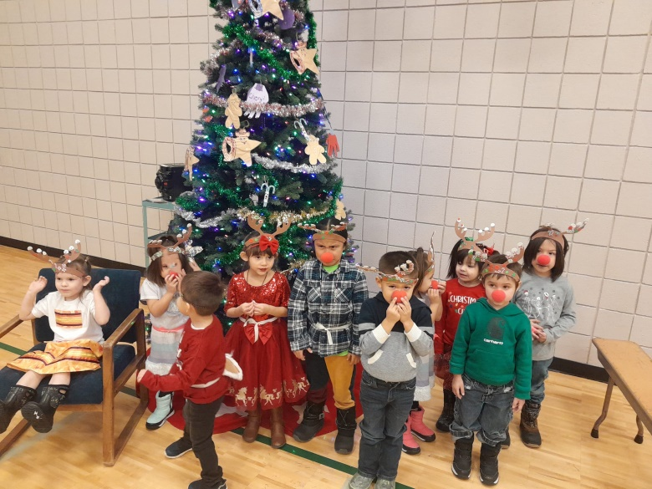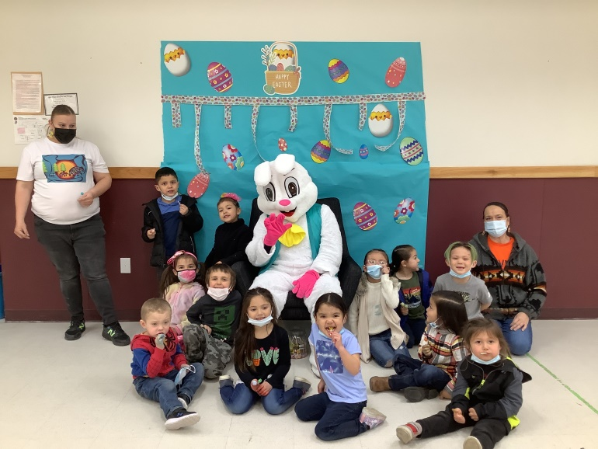

Your part...

- Make sure your child has a bedtime routine and is well rested. Preschool children need 10-13 hours (including naps) of sleep. Toddlers need 11-14 hours (including one or two daytime naps).
- Help your child eat wholesome nutritious meals to achieve strong and healthy bodies and immune systems. Head Start encourages family style eating at home.
- Dress your child appropriately for the weather and gross motor activities (running, tumbling, cartwheels, bike riding, if your child chooses to wear a skirt or dress, please have them wear shorts underneath). Children will go outside everyday with few exceptions. Generally, weather below 30ºF or in excess of 98ºF requires children to stay indoors. (Ask if you need assistance with coats etc.)
- Create opportunities for learning at home. Have frequent conversations with your child which include how, what, and why questions.
- Please keep your child at home if they are not feeling well and contact the program. Children should not come to school with a temperature higher than 100.4ºF, throwing up, have diarrhea, or eyes that are pink and crusty.
- Please label your child’s clothing.
- Be an active participant in your child’s ongoing assessment of health and education.
- Find a variety of opportunities to be involved in Head Start.
- Read to your child frequently and involve your child in reading.
- Complete two home visits with teaching staff each year in order for staff to better serve the needs of the family as a whole.
- Attend two parent/teacher conferences to review the work that your child is doing in class and go over records in your child’s file.
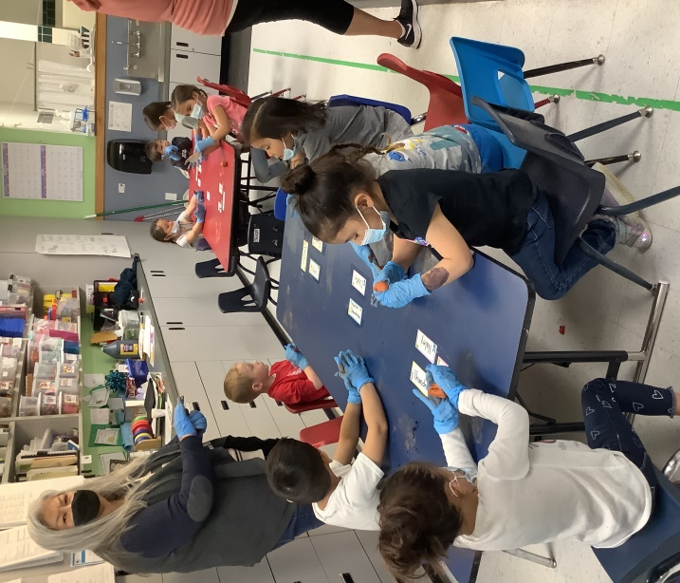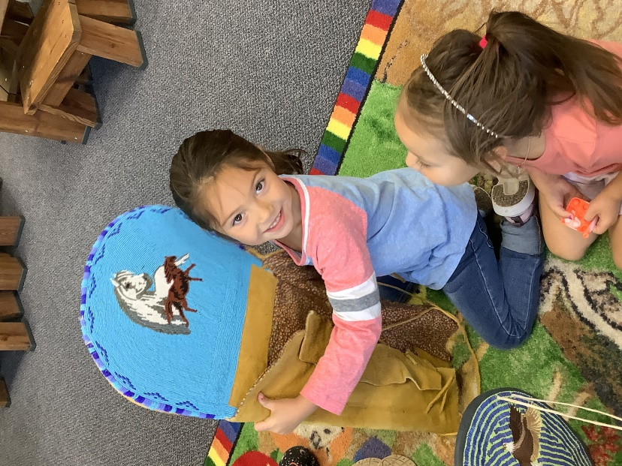
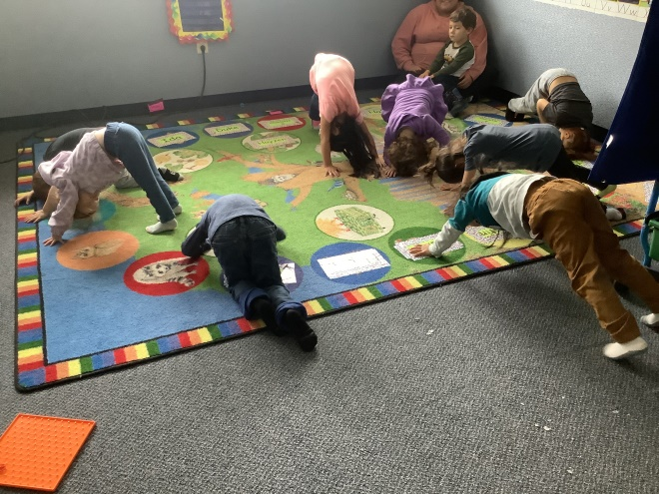

45 Day Requirements
- Developmental Screening
- Social Emotional Screening

Screening Tools
- Ages and Stages Questionnaire 3
- Ages and Stages Questionnaires: Social-Emotional 2
- Ages & Stages Questionnaires® (ASQ®) provides reliable, accurate developmental and social-emotional screening for children between birth and age 6. Drawing on parents’ expert knowledge, ASQ has been specifically designed to pinpoint developmental progress and catch delays in young children—paving the way for meaningful next steps in learning, intervention, or monitoring.

Assessment Tools
- Teaching Strategies GOLD
- Teaching Strategies GOLD is an authentic, ongoing observational system for assessing children from birth through kindergarten. It helps teachers to observe children in the context of everyday experiences, which is an effective way to learn what they know and can do.

Follow-up
- Family Support Staff will notify families as soon as possible following screening when further evaluation is necessary in any 45 day requirements.
- Family Support Specialists will support and guide families in referring children to outside agencies as needed for any concerns needing extra intervention from professionals outside the classroom, which may include speech, language, behavior or other interventions. Families participate in developing an Individual Education Plan (IEP) that addresses your child's individual needs and is integrated into classroom activities. Your child will receive early childhood special education services in their Head Start classroom with all their peers.

Curriculum

Colville Tribes Head Start has identified specific curriculums to meet the requirements of the program. Each curriculum has a timetable and plan for implementation.
Curriculum is a written plan that includes
- Goals for children’s development and learning,
- Experiences through which they will achieve these goals,
- Staff and parents responsibilities in achieving these goals; and
- Materials needed to support the implementation of the curriculum.

The Creative Curriculum® for Preschool, 6th Edition
The Creative Curriculum® for Preschool, 6th Edition provides a set of resources to support active learning through a variety of learning experiences. It includes six volumes that describe the curriculum foundation, interest areas in the classroom, objectives for development and learning and domain-specific teaching practices. The curriculum also provides teaching guides on six study topics with detailed daily plans.

Creative Curriculum® for Infants, Toddlers & Twos
The Creative Curriculum® for Infants, Toddlers & Twos is a comprehensive, research-based curriculum designed to help teachers and caregivers implement developmentally appropriate practices and offer responsive daily routines and meaningful experiences that nurture learning and development.

Second Step
Committee for Children's research-based Second Step® programs give teachers an easy-to-implement, engaging way to teach social-emotional skills and concepts. Second Step programs are designed to help children thrive and be more successful in school—ultimately setting them up to be thoughtful and productive adults.

Second Step Child Protection Unit
The Second Step Child Protection Unit curriculum for preschool/kindergarten focuses on teaching children basic skills designed to help them keep safe from dangerous or abusive situations. Despite good intentions to provide a safe environment for children, adults cannot always be there to protect children from every dangerous or abusive situation. Using the materials provided in the Second Step Child Protection Unit, parents, caregivers, child-care providers, and teachers can work together to provide the rules, information, encouragement, and practice that children need to help protect themselves.
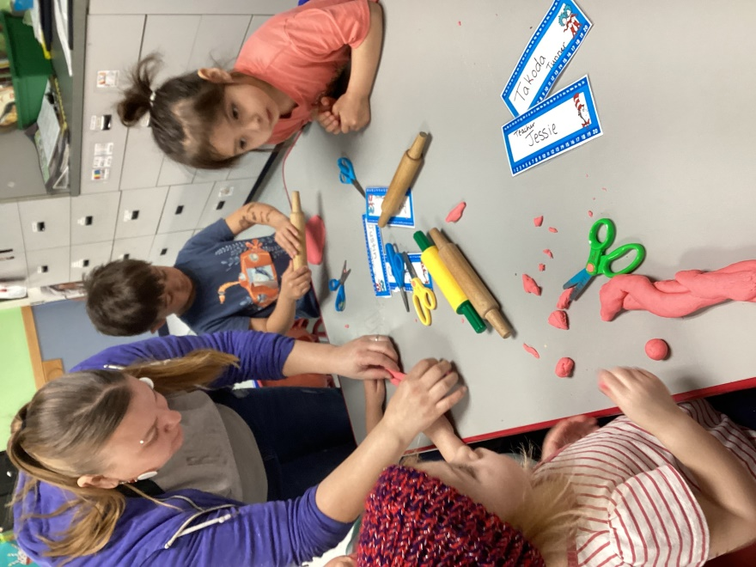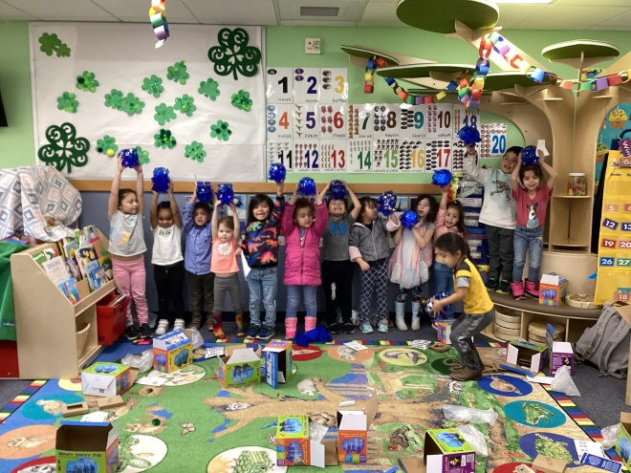
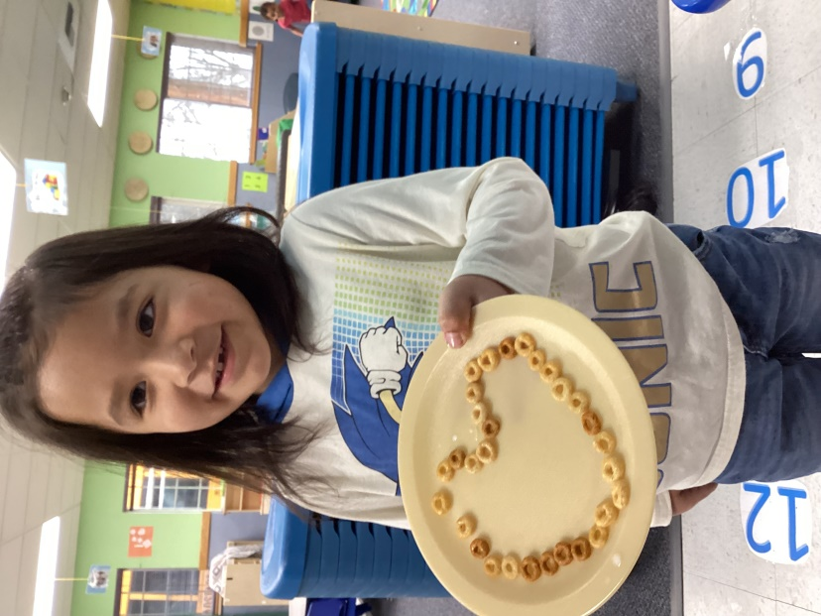

Since Time Immemorial Early Learning Curriculum
This early learning curriculum complements the “Since Time Immemorial” Tribal Sovereignty in Washington State Curriculum developed through the Office of Native Education/OSPI. It is the culmination of a shared vision of the Tribal Nations, Office of Native Education/OSPI, First Peoples First Steps Alliance, Thrive Washington, the Department of Early Learning, and Puget Sound ESD’s Native American Programs (Rebecca Kreth, former director of the PSESD Native American Early Learning Project). The Since Time Immemorial
Curriculum’s focus is to provide education and understanding of the history and tribal culture of the 29 federally recognized Native American Tribes in the State of Washington. Because of the diversity of the 29 tribes in the state each school district is encouraged to work directly with the tribes located closest to the school district.

Partners for a Healthy Baby
Partners for a Healthy Baby features materials for home visitors and families that promote child development and family well-being. The curriculum is organized around children's ages and topics home visitors can use to support both age-appropriate learning and family development

Curriculum Implementation
Each Head Start Teacher will review the curriculum, becoming comfortable with the implementation process before beginning instruction to the Head Start children.
Parents will have opportunities to review, discuss and provide input into the curriculum taught to their children, through the following methods.
- First home visit is in August,
- Parent Orientation; and
- Open House.
In the event a new curriculum is considered by the program, parents will have a chance to review the curriculum and offer input. Parents on Policy Council will be responsible for final parent approval prior to Colville Business Council Approval. New curriculums will not be implemented without proper approvals.

CLASS Observations
- CLASS® Observation completed twice annually to improve overall instruction. The Classroom Assessment Scoring System (CLASS®) is an observation instrument that assesses the quality of teacher-child interactions in center-based preschool classrooms.

Home Visits

Why is it important to do home visits?
Home visits are a good first step to developing a relationship between the staff, your child and yourself. It is useful for your child to see you welcoming us into your home as it shows that we are not strangers, but trusted adults.

Home Visit Philosophy
We believe that a partnership between parents and staff best supports children in their Head Start experience. Home Visits create a natural link between the two most powerful influences in a child’s life, home, and school. Home Visits also support the development and achievement of personal and family goals. Your active participation in home visits is very important to your child’s Head Start experience.
Teachers will come into your home for a Home Visit 2 times during the school year. The Home Visit is a time to get to know your child’s teachers better and to share your knowledge of your child. Teachers will do ASQ-3 and ASQ:SE-2 questionnaire while at the home visit to help parents understand where their child is developmentally and social-emotionally.

Home Visits last ½ - 1 hour. This gives you time to catch up on what is going on in the classroom and to help the teacher plan and develop goals for your child, and for your family, if you wish.
You will need to decide the best time of the day for the Teachers to come to your home. Avoid times that you usually eat, watch a favorite TV show, or do chores. You might want to choose a time when your other children usually take a nap or are in school so you can devote special time and attention to your Head Start child. Some families like to plan visits when both parents are home. At your request, an alternate location may be chosen.

Parent Teacher Conferences

Why are parent/teacher conferences important?
- A parent-teacher conference is a great opportunity to: share academic progress and growth based on classroom observations, testing data, assessments, portfolios, and assignments. learn from parents or guardians so you can be better informed about students' strengths, needs, behaviors, and learning styles.
- Discuss enrichment or intervention strategies to support students' learning
- Discuss issues that may be interfering with students' learning and growth

Child Guidance and Behavior Management
Our classroom environments, schedules and activities are designed to capture the interest and stimulate the enthusiasm of young children. Our teachers instruct the children on how to use materials, classroom and equipment and what rules need to be followed when they interact with them. They also teach social skills that will help the children to have successful interactions with all the adults and children.
Occasionally young children forget the rules and test limits; this is developmentally appropriate. It helps to learn to respect limits and develop social skills that will help them be successful in our classes and the rest of their life. The strategies we use to help children learn to respect limits include:
- Clear expectations
- Consistent schedules, rules, and routines
- Positive reinforcement
- Problem solving with the child or children
- Giving choices within limits
- Teaching positive social skills
- Redirecting them to appropriate activities
- Removal from the activity/area in the classroom
- Developing behavior plans
Our staff will maintain communication with parents/guardians about behavior plans for their children if needed (See Behavior Policy and Procedure). Federal Head Start Program Performance Standards prohibit the use of corporal punishment or total or extended isolation as a child management tool. The withholding of food, basic needs or participation in special events, name-calling, ridicule, or any form of demeaning, harsh or frightening treatment is strictly forbidden. Within the Colville Tribes Head Start program, any use of corporal punishment will result in immediate termination of employment.
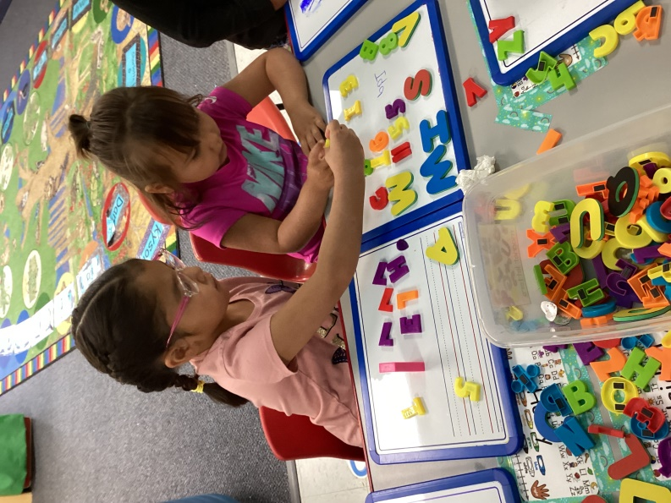

Attendance
Good attendance leads to lifelong learning and positive habits necessary for school and work. Regular attendance allows children to benefit from participating in quality early education. Research shows that students who miss too many days of preschool have weaker literacy and numeracy skills entering kindergarten.
Your child’s teacher will contact you within one hour of the start of school if you have not notified the program if your child will be absent for the day. This is for health/safety concerns.

What can you do to help?
- Contact Teacher or Family Support Staff when your child is absent and identify the reason for absence.
- Do not let your child stay home unless truly sick.
- Identify ideas for a consistent morning and night routine, children need structure which then helps with behavior concerns and parents stress level.
- Have a backup transportation plan.
- Pack school bags and clothing the night before.
- Keep track of your child’s absences; try not to miss more than 2 days per month, your child and family are building habits now that they will carry with them throughout their schooling career.
- Remember, what they are learning now in Head Start will prepare them for Kindergarten, from social interactions, to learning letters & sounds for reading.
Once again contact your Family Support Specialist for any support, that's what they are here for!

Absenteeism
A child’s enrollment status shall not be removed from Head Start without the approval of the Family Service Specialist, Site Supervisor, ERSEA Specialist and/or Program Manager. Only after all avenues have been exhausted, will a child be dropped from the program. This includes, telephone conversations, home visits, contacts, Family Service Specialist/Teacher home visit, drop letters and referral to additional educational resources. After all the above-mentioned situations have occurred, and the family remains out of compliance, Head Start Staff will take into consideration the documentation of the above instances and make a final determination. No child will be dropped from the program without first having had the opportunities given in the order outlined above. Attendance Policy will be presented at parent orientation and parents will sign the Permit and Agreement form and confirm their understanding of the policy.
HEAD START PERFORMANCE STANDARDS REQUIRE THAT PROGRAMS MUST MAINTAIN A MONTHLY ATTENDANCE RATE 85%.
A student with more than 18 excused or unexcused absences may be dropped from the program, thus allowing a waitlist student the opportunity to enter the program.

Disabilities
Head Start and Early Head Start programs are required to ensure that at least 10% of enrollment slots are occupied by children with disabilities. In fact, Head Start's founders and early pioneers recognized that both children with and without disabilities would benefit from participating together in the same classrooms. Since 1972, over 3 million children with disabilities have fully participated in Head Start.
Nearly half of the children with disabilities in Head Start and Early Head Start are diagnosed after they enroll in the program. This usually occurs through Head Start and Early Head Start screening or the ongoing assessment and referral process. Families, teachers and other Head Start staff will work together to determine whether a referral or assessment is needed
Family Support Specialists will ensure you understand your rights to obtain an evaluation, the benefit of receiving services as early as possible, and how you participate in the decision making process and location of where you would like to have special services for your child.
Family Support Specialists are available to help you advocate for your child during the referral process and any follow-up actions needed. Head Start will work with other agencies or health care providers, as well as families, to best ensure that a child’s needs are being met.
If you have any concerns or questions about your child’s development, please discuss them with your teacher or a Family Service Specialist If you know of a child in the community who you have observed to have concerns with development please refer the parents to our program.
We work in conjunction with the State and the local education agency in meeting the special educational needs of Indian children, age birth to five with disabilities. These services may include Well- Child clinics, screening, parent training and the provision of direct services. The Health/Disabilities Specialist and Family Support Specialist are available to help with paperwork and attend meetings to advocate for the best interest of the child.

Transportation
Head Start will pick up and deliver each child to the specified location as indicated on your application. Transportation is not provided for Early Head Start, Birth to Three, Home Visiting, or Prenatal programming.
- Each family is allowed two (2) permanent location changes each year. Transportation will be the responsibility of the parent for temporary or additional changes.
- The bus will wait only three (3) minutes for a child unless weather or other conditions affect the bus schedule.
- Permanent changes must be received in writing one (1) week in advance.
- No food, drink, candy or toys are allowed on the bus.
- An adult must be visible when picking up and dropping off a child. A child will NOT be left where an adult is NOT visible, and the child will be returned to the center at the end of the bus route. Adults according to the law are those persons 13 years and older. Bus drivers are to use their common sense to determine if a person is a suitable caretaker. (e.g. someone physically or mentally disabled may not be a suitable caretaker for a child 3 or 4 years of age.) Parents are responsible to pick up their child when returned to the center.
- Children left at the center after hours will be turned over to Children & Family Services after attempts to reach the emergency contacts or home. Please call the center if there are problems, we can assist you with, to ensure the safety of your child’s arrival to and from the head start center.
- The Intoxicated Caretaker Policy states that no child will be left with a caretaker that is influenced by alcohol or drugs. This document is signed by you upon enrollment for Head Start. If you need another copy, please contact the Head Start Office or your center.
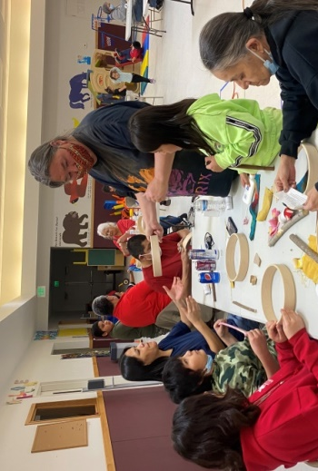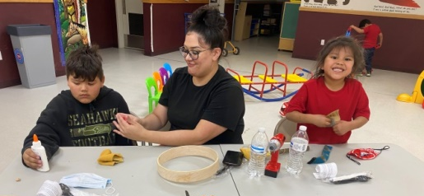
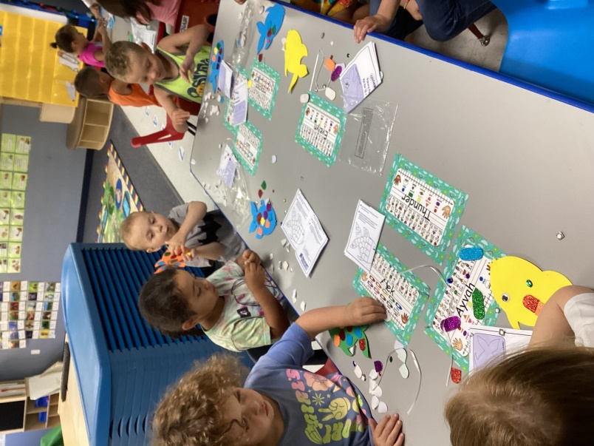

Health Services

Screening and Ongoing Health Care
Head Start identifies children with special needs early in the program year by completing a multitude of screenings and assisting families as needed with obtaining necessary medical and dental care. Ongoing access to medical and dental care is essential for all children, regardless of income. Head Start will assist you in getting and keeping a medical and dental home. Please let your Family Support Specialist (FSS) or Teacher know of any barriers that have prevented you from getting medical or dental care in the past so that together we can develop a plan to overcome those barriers.

If you already have a medical and dental home, please make an appointment with your medical and dental providers to take your child for a well-child exam and a dental exam.

If your child has had a medical or dental exam within the last year, the FSS will have you fill out a release of information form and we will get that documentation directly from your health care provider.

30 Day Requirements
- Ensure families have ongoing source of continuous health care (a medical and dental home),
- Establishing a Primary Physician; and
- Obtaining Health Insurance

45 Day Requirements
- Vision Screening
- Hearing Screening
- Growth Assessment

90 Day Requirements
- Comprehensive Dental Exam
- Comprehensive Physical Exam including Lead Screening and Hematocrit Test
- Nutrition Assessment

Early Head Start Requirements
- Tracking and Support for Well-Child visits at 1, 2, 4, 6, 9, 12, 15, 18, 24, and 30 months.

Allergies
Please report any allergies that your child has to the Family Support Specialist. A written documentation must be provided by a doctor verifying the allergy and any side effects head start may need to be aware of. All pertinent staff will be made aware of allergies and trained on any special needs or medications related to severe allergic reactions.

Immunizations
- Children’s immunizations must be current or up to date as required by CDC and Office of Superintendent guidelines for childhood Immunization Schedule.
- Children, whose immunizations are not up to date, must develop a plan with a medical provider. The child must adhere to the plan and the plan submitted to the program for the child to continue attending the program.
- Exemptions:
  - Religious
  - Medical
  - Personal Reasons (MMR vaccine no longer exempted for personal reasons, House Bill 1638).
- Children not fully immunized will be excluded during an outbreak; children will be excused until there is no risk to the child.
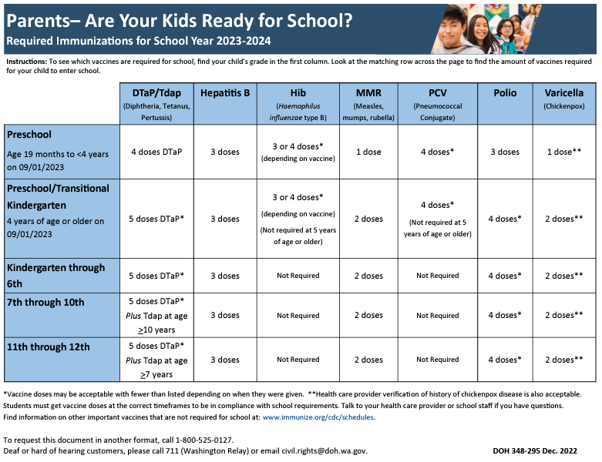

Follow-up
- Family Support Staff will notify families as soon as possible following screening when further evaluation is necessary in any 30, 45, or 90-day requirements.
- Family Support Specialists will support and guide families in referring children to outside agencies as needed for any concerns needing extra intervention from professionals outside the classroom, which may include Optometrists, Otolaryngologists, general family practitioner, or Dentist.
- Family Support Specialists will help families achieve a continuous schedule of health care for their children.
- Family Support Specialists will help families work with a medical provider on an immunization plan when needed.

Nutrition:
Parents are provided with information concerning diet and general nutrition. All meals and snacks meet or exceed CACFP guidelines. Menus are reviewed and approved annually by a registered dietician.

Meal Components:
- Infant
  - Breakfast/Lunch: Breast Milk/Formula, Infant Cereal/Meat/Meat Alternate, and Vegetable/Fruit
  - Snack: Breast Milk/Formula, Grain and Vegetable/Fruit.
- 3-5 Year Olds
  - Breakfast: Milk, Fruit/Vegetable, and Grain
  - Lunch: Milk, Fruit and Vegetable, Meat/Meat Alternate, and Grain
  - Snack: Any two meal components

Family Style Meals:
Center Based (9am-1pm) programming serves Breakfast and Lunch. Center Based (9am-3pm) programming serves Breakfast, Lunch and afternoon snack. Center Based (8am-4pm) programming serves Breakfast, AM Snack, Lunch and afternoon snack. Infants are fed on demand.
Family style eating with balanced, nutritious meals gives children an opportunity to learn about healthy eating habits with support from their peers. Children serve themselves and join in conversation with other children and adults sitting at the table. This is an opportunity for children to develop language skills and to practice skills like passing the serving dishes, serving themselves, asking politely for things, and generally enjoying a good social experience.
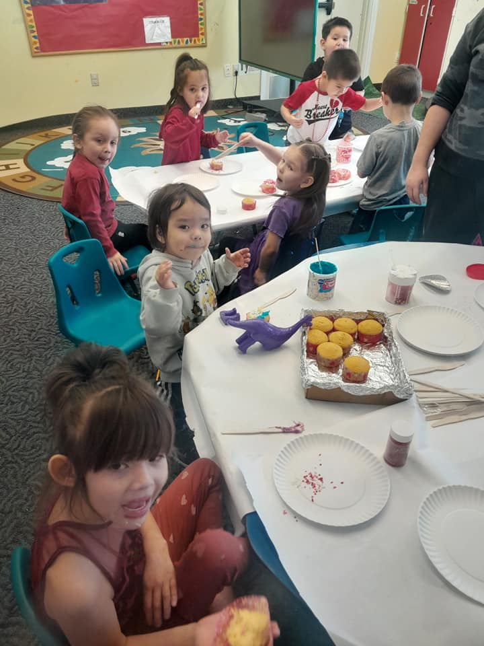

Medical and Dietary Considerations:

Milk Substitution:
If your child cannot drink fluid cow’s milk due to medical or other special dietary needs but does not have a diagnosed medical disability, you or the childcare center may choose to provide one of the approved non-dairy milk substitutes or creditable milk substitutes below, based on your request.
At this time, only five brands of non-dairy milk substitutes available in Washington are nutritionally equivalent to and may be served in place of cow’s milk:
- 8th Continent Soymilk (Original and Vanilla*)
- Great Value Original Soymilk
- Kirkland Organic Soymilk (Plain) • Pacific Ultra Soy (Plain and Vanilla*)
- Silk Original Soymilk

Medical Disability
An individual with a disability is described under Section 504 of the Rehabilitation Act (1973) and the Americans with Disabilities Act (ADA) as a person who has a physical or mental impairment that substantially limits one or more major life activities/bodily functions. Refer to the end of this document for definitions of “disability” and “major life activities/bodily functions”. Children needing a medical substitution must fill out a Medical Disability Statement and have it signed by a medical authority.

Medical Non-Disabling Statement
Children with an identified condition that is medically certified (but not a disability) that requires a special dietary accommodation. Children needing a medical non-disabling substitution must fill out a Medical Non-Disability Statement and have it signed by a medical authority.

Oral Hygiene:
Children in center based programming brush teeth after meals and snacks. Head Start uses fluoride toothpaste. Fluoride can greatly help dental health by strengthening the tooth enamel, making it more resistant to tooth decay. It also reduces the amount of acid that the bacteria on your teeth produce

Illness
Please keep your child home if he/she is ill. If your child is brought to the classroom when sick, or becomes ill while at school, we will require that she/he be taken home immediately. Your child is not well enough to be in class if any of the following symptoms are noted:
- Fever over 100.4 degrees
- Sore, red throat (even without fever)
- Earache
- Deep hacking cough
- Severe congestion
- Difficulty breathing or untreated wheezing
- An unexplained rash
- Stiff neck, headache with one or more of the above symptoms (seek immediate medical care)
- Diarrhea (more than two times in 24 hours)
- Vomiting (more than one time in 24 hours)
- Thick drainage from the eye
- Thick, green drainage from the nose with sinus pressure
- Contagious infection or disease (Let your teacher know!)
Notes: If allergies are identified as a cause and the symptoms continue with a child, Head Start staff will request documentation from a physician stating cause of allergy, symptoms, treatment, and side effects.
Be sure to keep your emergency contact information updated so that we can let you know if your child is ill. In some cases, a letter from a health care provider will be needed to ensure that your child is not contagious before he/she returns to class.
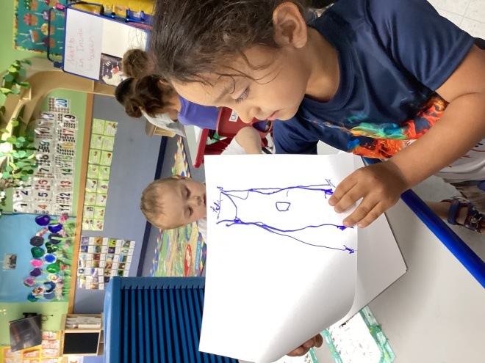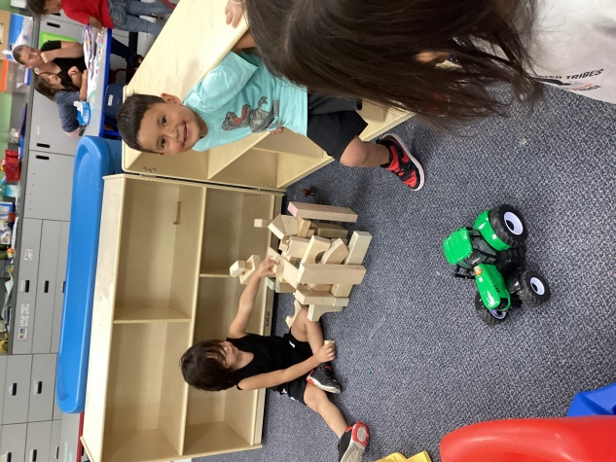

Medication Administration
Whenever possible, medication and medical procedures will be provided by the child’s family at home, before or after school. Medication will be given at school only when the student's health would be compromised by not getting the medication or procedure during school hours. An authorization for Administration of Medication as School form will need to be completed by a Licensed Health Professional in the event medication is necessary during programming hours.
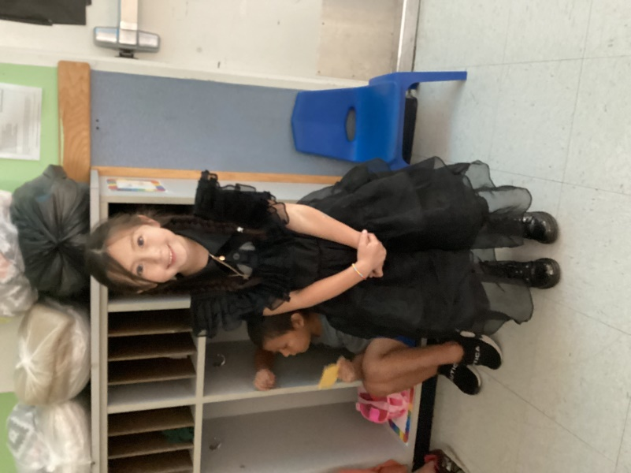

Lice
Parents are encouraged to check their child’s head on Sunday, before school on Monday and whenever lice are suspected. Head Start staff will conduct daily health/safety checks as outlined in the CCT Head Lice Policy. During this daily check if a staff member notices a child consistently scratching their head, a closer examination of the child’s head will be conducted. The following guidelines will be followed if head lice or nits are suspected.
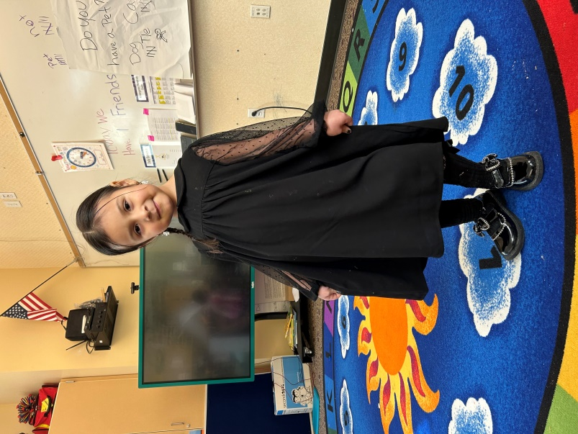
- Contact family at their soonest opportunity to notify the parent of suspected head lice or nits.
- Parents can choose to pick up the child immediately or let the child finish the school day.
- Provide family with information on the removal of head lice and best practices for eradicating head lice from the home.
- Provide parent/guardian with head lice kit when available.
- Notify all pertinent staff of incidents of head lice.
- Allow child to return to school once treatment has started as documented on the “Head Lice Treatment Verification and Readmission” form.
- Head Start will maintain confidentiality when Head lice are found.
- Site Supervisor w/recommendations of Health/Disabilities Specialist will determine whether to send a note home to all parents and the necessary steps to follow.
- Classrooms and Buses will be cleaned following procedure in CCT HS Head Lice Policy.
- The Family Support Services (FSS) staff will work with the parents to offer resources and assistance necessary to eliminate the head lice.

Mental Health:

Mental Health consultants are available through the Head Start program to help teachers and parents encourage behaviors, which move children in the direction of cooperation, making friends and appropriate choices, developing a strong sense of self-esteem and for social/emotional growth. A signed permission will be requested before any observations are conducted of the classroom (please see our Permit and Agreement form). Occasionally families may need to be referred for more intensive services outside the program. The Mental Health Professional and Family Support Specialists will help families through this process.

Annual Classroom Observations
Mental Health Observations completed twice annually to ensure teachers are using proper techniques in guiding children and to ensure the environment is optimal for healthy learning.

Handling Separation

Here are some things you can do to help make separation easier for your child, as well as your own state of mind:
- Focus on the positive. Your child is having difficulty because he or she has bonded with you – know that your influence is, and will continue to be, important to your child’s development.
- Know that children are often sensitive to their parents’ moods. If mom’s response is made in a reassuring, unexaggerated and matter-of- fact way when leaving, such as acting like she is going into another room, then her mood won't signal to her child, "Hey! Something big is happening!"
- Do less talking and more walking. Often, parents drag-out the leaving process, turning it into an event with talking, extra hugging and coming back and forth to see to their crying child. This attention usually makes things worse. The hardest, but perhaps best, thing to do when leaving your child is to leave quickly.
- Put yourself in your child’s shoes. In the interest of making “leaving time” easier, do more brief coming and going activities when you aren’t really leaving the house. As your child becomes satisfied that you always return, he or she may become less anxious when you leave.
- If your child struggles with leaving the parent at drop of time one thing that could help, make it easier on the parent and the child is to be consistent with the times of pick up and drop off that way they can develop a routine
- Redirect. Teachers will involve children in a new and engaging activity to redirect their attention if they are upset by your leaving. Feel free to talk to your child’s teacher about any concerns you may have about your child’s transition into the school setting. While the transition from home to school might still be difficult, these tips may help the process become one of closeness, caring and growth.

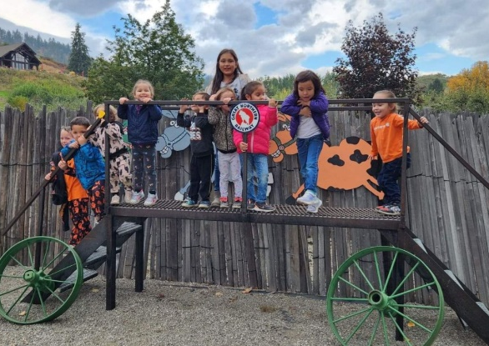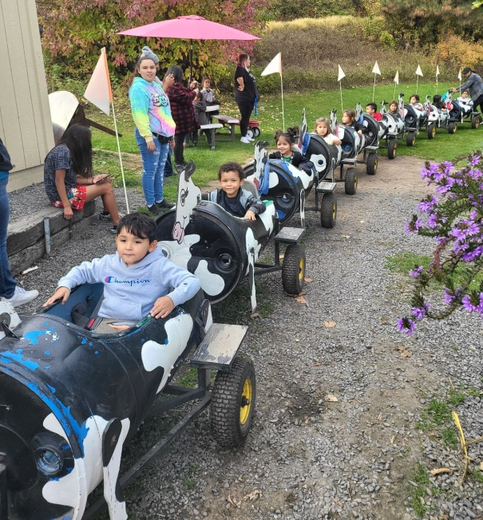
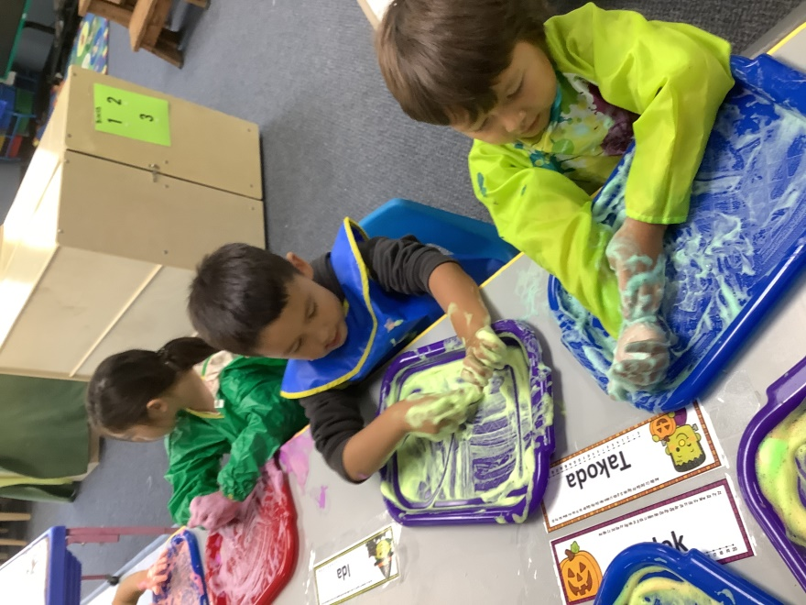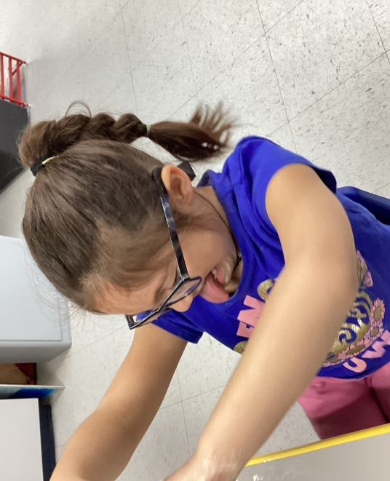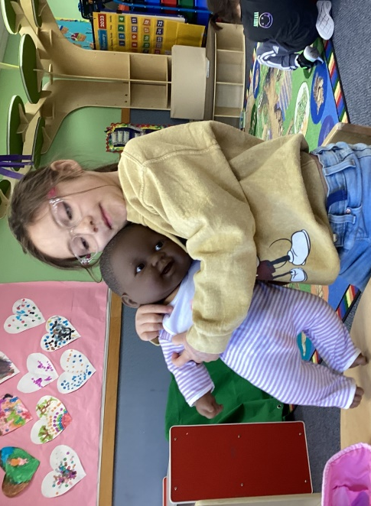

Safety
We use the classroom to teach children healthy habits around safety. We ensure that playground rules are followed and safety devices such as helmets are used appropriately. Parents may review materials used to teach personal safety prior to their use in the classroom.
Visitors and vendor access to the Head Start classroom or playgrounds will be limited. Staff will monitor the entry and exit of children and families during operational hours. In the case of extraordinary circumstances, the center and playground will be completely locked down if local circumstances require extra precautions or if notified by local police departments of hazardous circumstances that may jeopardize the safety of children and adults during school hours. Parents will be notified should this happen.

Handwashing
Handwashing is done upon arrival at school and routinely throughout the day
Top Three Reason for Handwashing
- Handwashing can keep children healthy and in school. Handwashing education can reduce the number of young children who get sick and help prevent school absenteeism.
- Handwashing can help prevent illness. ...
- Handwashing is easy!

Child Release
Head Start staffs are authorized to release children only to the custodial parent or those individuals listed on the Child Emergency Card or the Child Release Information Form. If a staff member is unfamiliar with the individual attempting to pick up a child, they may ask that person to present identification. If in doubt, staff will always check the Child Emergency Card or the Child Release Information Form.

Medical Emergency
Staff have trained to follow emergency procedures. A staff person will stay with the injured child at all times and administer first aid as necessary. Staff will seek medical assistance from:
- Emergency medical services (911)
- Hospital emergency room or clinic, or
- Poison control.
Staff will contact the parent/guardian as listed on the child's emergency contact form. If the staff is unsure about the urgency of a situation, they will call the listed physician on the child emergency form or the Health Consultant, parent/guardian, or other adults listed on the emergency form.

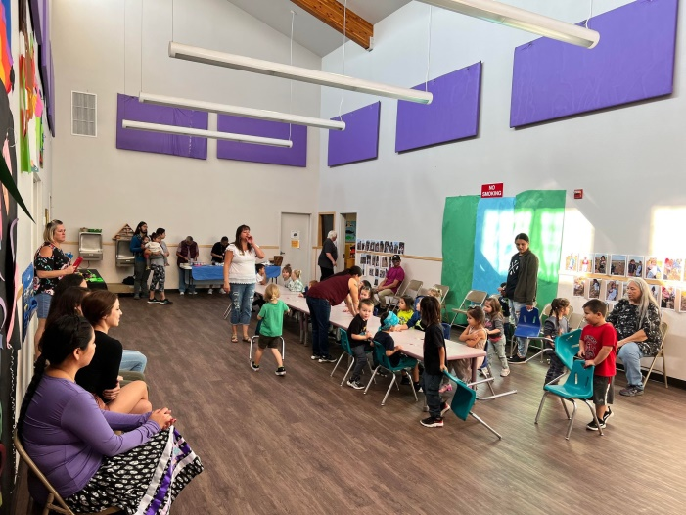

Family Partnerships

Head Start is committed to supporting your family by establishing a strong partnership with you. We will help you identify your goals and support you in reaching them by using your own strengths and needs. This will reinforce the gains made by your child at Head Start and support your own personal goals and well-being. Head Start Teachers and Managers are available to help with information and resources. Family Support Specialists will check in frequently by phone, at the center or on home visits to check on goal progress throughout the year.

Family Support Services
- Advocacy and support with other agencies or individuals.
- information and Resources for family and children's needs.
- Emergency or crisis intervention.
- Encouragement and support for your own efforts to obtain the quality services you desire.
- Development of family goals and strategies that you identify as areas for personal growth.
- Head Start parent meetings with educational topics.
- Support for child development, discipline, and stress management issues.
- Information and financial resources to support your training and educational needs.
- Computer and Internet access.
- Assistance with medical and dental needs for those children not covered by the Colville Tribal Plan or other insurance.
- Support for fathers and significant males in parenting roles.
- Support with Cultural and Native Language resources.

Family and Child Outcomes
It is important that programs and families work together toward key outcomes (i.e., results). Research shows that when families are safe, healthy, and financially secure, they have a better chance of thriving. Strong families can build positive relationships with their children, peers, and communities. Strong families help children succeed in school and in life.

The 7 family outcomes that Head Start focuses on are the following:
- Family Well-being,
- Positive Parent-Child Relationships,
- Families as Lifelong Educators,
- Families as Learners,
- Family Engagement in Transitions,
- Family Connections to Peers, and Community and
- Families as Advocates and Leaders.

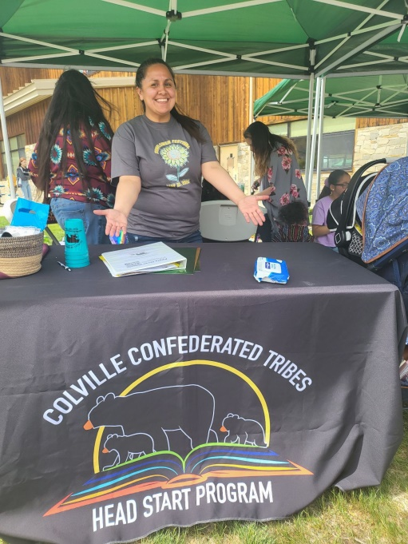

Family Involvement
Parent involvement helps extend teaching outside the classroom, creates a more positive experience for children and helps children perform better when they are in school.
Some of a child’s most important cognitive development happens during their early years. By taking an active role in the education process, families can help ensure that their child has all the support they need to develop to their full potential.
Families are encouraged to become active in their community, to advocate for their children and low-income families and positively impact the communities in which they live.

Volunteering
Volunteers provide the extra attention that helps children thrive as learners and grow to be strong healthy individuals. As a volunteer, you can make a huge difference in the success of the Head Start Program.
As a volunteer, you will meet other people with similar interests. You will learn from teachers, children, and other parents, gaining skills that can be used at home or in the community, and teachers, children and other parents will learn from you. Volunteering can be considered work experience and enhances your resume’.
Some of the things you can do as a volunteer are:
- Read stories to children: choose books from library
- Make or repair materials for the classroom; teach
- Share special interest
- Be a photographer at Head Start event
- Help with making regalia, baskets, drying meat, hunting, digging, etc.
- Help with yardwork and building maintenance
- Cook or bake with children
- Lead music or songs; play games with children
- Chaperone field trips

Volunteer vs Visitor/Guest
- Volunteer
  - Any non-staff individual 18 years or older (including parents/guardians of program children) who intends to perform duties for the program. Volunteers, including Practicum students are not replacements for staff, they may not be counted as part of the staff to student ratio.
  - Must have management approval and are required to complete all CCT ECE/HS background checks and complete orientation with Site Supervisor in district volunteering.
- Visitors/Guest
  - Program parents/guardians, who do not meet the definition of Volunteer, will not perform program duties nor have unsupervised contact with children in the program other than contact with their own child. They may visit locations/classrooms where their child/children currently are in attendance. Parents/guardians are welcome at the center at any time. Siblings are not allowed at the center except for special activities.

Policy Council Member
The Policy Council is a group of Head Start and Early Head Start family and community members who help lead and make decisions about their program. Policy Council members are elected by the families of children enrolled in the program. Families often join the Policy Council after serving on a parent committee.
The Policy Council meets monthly as a group. Members can serve for one year at a time, and for up to five years. They work closely with the program's management team and governing body to provide overall direction for the program.
Policy Council is involved in decisions involving program budget, hiring, and program planning and policies. Policy Council also actively participates in the annual program self- assessment. Policy Council are elected at each site by the parent committee. Policy Council is a great opportunity for advocacy and training opportunities.

Health Services Advisory Committee
The Health Services Advisory Committee is an advisory group that brings together staff, parents, and local health care providers to talk about the planning, operation, and evaluation of the health services in each Head Start program.
This committee consists of Parents, Community Professionals and Head Start staff. They meet to talk about program issues in the medical, dental, mental health, nutrition, and human services fields. Health Services Advisory Committee meets once or twice per year.

Parent Committee
Members make suggestions for curriculum and classroom activities. They may organize social events, classes, workshops, guest speakers, or community projects. Each center operates its own Parent Center Committee; all parents of children currently enrolled have voting privileges. Upon acceptance of your child into Head Start, all parents are automatically parent committee members.

Children’s Activities
- Have Breakfast/Lunch with your Child(ren). (Check with the teacher before bringing extra child(ren) to class when visiting.)
- Families are encouraged to participate in the Head Start Program as classroom observers. This is an opportunity for families to see how their child interacts with other children and staff.
- Families can volunteer in the daily schedule of activities with children. There are many ways in which families can volunteer. When appropriate, parents can be used as substitutes in the classroom, or in the kitchen.
  - Families interested in a career in the field of Early Childhood Education are encouraged to apply for Short Notice positions within the program. This allows families to gain work experience and take advantage of the same education opportunities offered to full-time staff.
- Reinforce skills your children have learned at school, and encourage the development of new skills. Families are the first and best teachers of their own children.
- Keep informed by reading information sent by the program.

Parent Activities
- Set goals and check in on progress made with your FSS
- Participate in home visits and parent/teacher conferences
- Attend orientation and open house
- Attend parenting, financial, and/or other classes offered by the Head Start
- Attend special events at the Head Start, such as carnivals, winter celebrations, end of the year celebrations, and/or guest speakers.
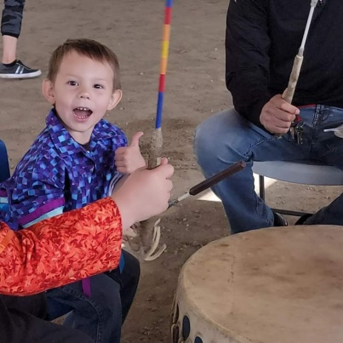
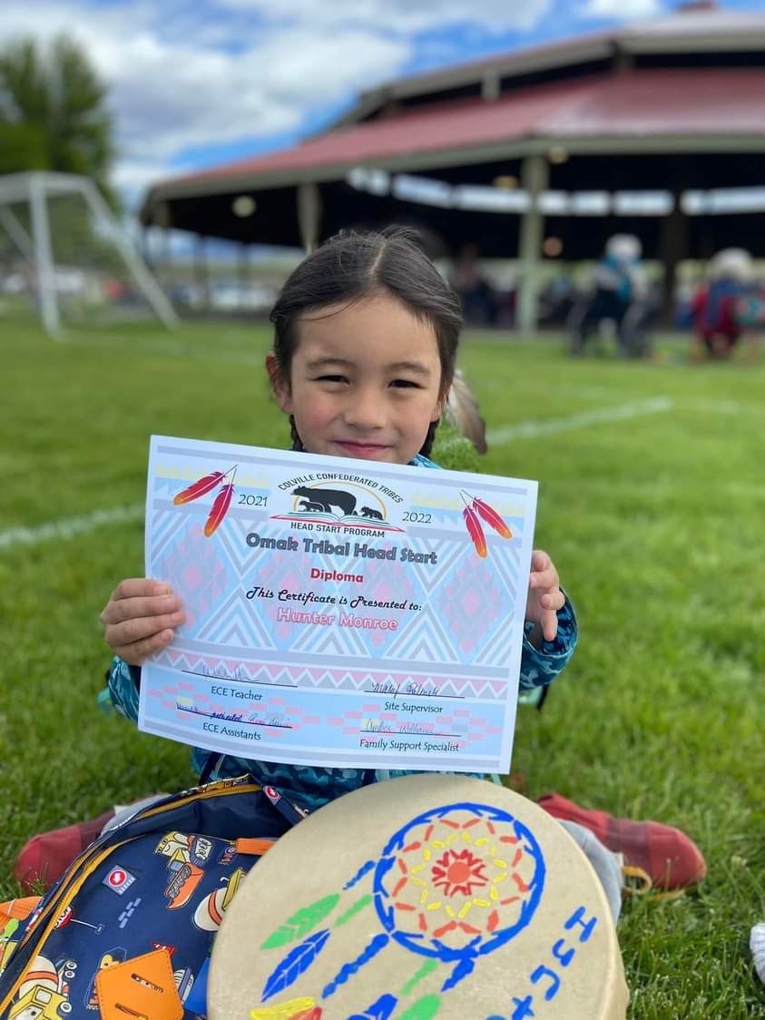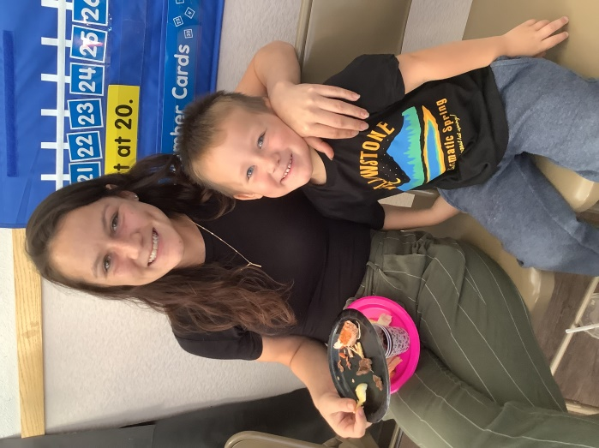

Important Policies

Civil Rights
In accordance with federal civil rights law and U.S. Department of Agriculture (USDA) civil rights regulations and policies, this institution is prohibited from discriminating on the basis of race, color, national origin, sex (including gender identity and sexual orientation), disability, age, or reprisal or retaliation for prior civil rights activity.
Program information may be made available in languages other than English. Persons with disabilities who require alternative means of communication to obtain program information (e.g., Braille, large print, audiotape, American Sign Language), should contact the responsible state or local agency that administers the program or USDA’s TARGET Center at (202) 720-2600 (voice and TTY) or contact USDA through the Federal Relay Service at (800) 877-8339.
To file a program discrimination complaint, a Complainant should complete a Form AD-3027, USDA Program Discrimination Complaint Form, which can be obtained online at: https://www.usda.gov/sites/default/files/documents/USDA-OASCR%20P-Complaint-Form-0508-0002-508-11-28-17Fax2Mail.pdf, from any USDA office, by calling (866) 632-9992, or by writing a letter addressed to USDA. The letter must contain the complainant’s name, address, telephone number, and a written description of the alleged discriminatory action in sufficient detail to inform the Assistant Secretary for Civil Rights (ASCR) about the nature and date of an alleged civil rights violation. The completed AD-3027 form or letter must be submitted to USDA by:
mail:
U.S. Department of Agriculture
Office of the Assistant Secretary for Civil Rights
1400 Independence Avenue, SW
Washington, D.C. 20250-9410; or
fax:
(833) 256-1665 or (202) 690-7442; or
email:
program.intake@usda.gov

USDA is an equal opportunity provider, employer, and lender. This institution is an equal opportunity Employer.
In accordance with Washington State civil rights law and OSPI this institution provides equal access to all programs and services without discrimination based on sex, race, creed, religion, color, national origin, age, honorably discharged veteran or military status, sexual orientation, gender expression, gender identity, the presence of any sensory, mental, or physical disability, or the use of a trained dog guide or service animal by a person with a disability. Questions and complaints of alleged discrimination should be directed to:
Office of Equity and Civil Rights
P.O. Box 47200
Olympia, WA 98504-7200
360-725-6162/TTY: 360-664-3631

Discrimination Complaint Procedure
Anyone who wishes to file a complaint alleging discrimination by OSPI on the basis of sex, race, creed, religion, color, national origin, sexual orientation, gender expression or identity, honorably discharged veteran or military status, status as a mother breastfeeding her child, disability, or the use of a trained dog guide or service animal by a person with a disability may do so by following OSPI’s Discrimination Complaint Procedure.
This institution is an equal opportunity provider.

Affirmative Action and Non-Discrimination
Colville Tribes ECE/HS/EHS provides equal access to all programs and services without discrimination based on sex, race, creed, religion, color, national origin, age, honorably discharged veteran or military status, sexual orientation, gender expression, gender identity, the presence of any sensory, mental, or physical disability, or the use of a trained dog guide or service animal by a person with a disability. Questions and complaints of alleged discrimination should be directed to:
Office of Equity and Civil Rights
P.O. Box 47200
Olympia, WA 98504-7200
360-725-6162/TTY: 360-664-3631

This policy applies to all program activities and services, whether carried out by Colville Tribal Head Start directly or through a contractor or any other entity with which Colville Tribal Head Start arranges to carry out its programs and activities. If you have any Questions - please contact your ECE Site Supervisor.

Confidentiality
Information is gathered so that Head Start can completely understand the needs for your child and family and work with you to meet those needs. All information obtained from you is completely confidential. All staff are required to sign an “Oath of Confidentiality”. At the end of the school year, records are locked in the Head Start Office for three years and three months, and then destroyed. It is also expected that families will not discuss anything that they learn about another family from their participation in the Head Start program.

Notice of Privacy Practice
This notice describes how health and education information about your child may be used and disclosed and how you can get access to this information. Please review this information carefully.
The collection and use of information about children and families is limited to that required to provide educational, health and family services. Any information obtained in the performance of official duties is considered confidential. This includes, but is not limited to, written and verbal information gained as a result of observation, screening, assessment, informal conversations, conferences, or meetings.
Anyone who may access your child’s records must first sign a confidentiality agreement. People who may have access to your child's records are: Head Start employees and consultants who are working with your child or monitoring the quality of service delivery, education service district or regional program staff from whom your child receives services, auditors or courts of law through the subpoena process, state and local education authorities, health and safety officials. Child education and health information will be disclosed to law enforcement, child protective services, health care professionals, and other appropriate parties in connection with a health and safety emergency if knowledge of the information is necessary to protect the health and safety of the student or other individuals.
Student Education Records

Directory Information
The following information is considered Directory Information. You will be given an opportunity to consent to program use of the following information on enrollment forms:
- The Class List will include your child's name and date of birth, parent name, home and mailing address and phone number. These lists are available to staff and used for student information and parent contact.
- The Information/Emergency Form is kept in a notebook near the classroom phone, and in the bus binder/field trip folder/ clipboard, outdoor play/field trips. This is for safety and emergency use. Information that would be needed in case of an emergency will be noted on this form.
- Your child may be photographed or videotaped for classroom projects, parent or staff training purposes, class pictures to be sent home to families, or media coverage.
- You may allow your name, address and phone number to be shared with other parents for parent activities. Membership on a committee will be considered consent unless the program receives written instructions not to release this information.
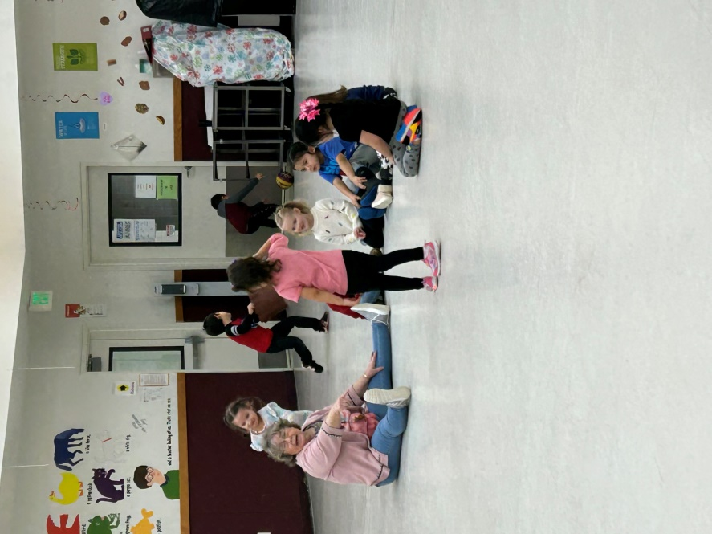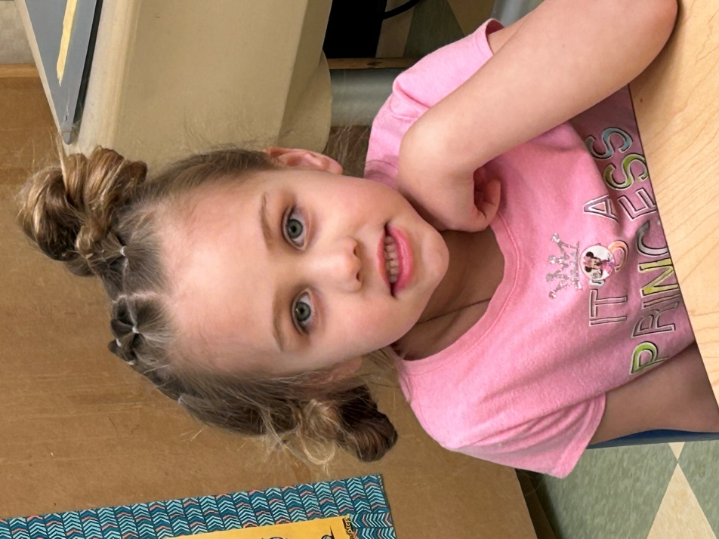

Parents Rights
A "parent" of a student is defined as a biological parent, legal guardian, or individual authorized in writing to act as a parent in the absence of the parent or guardian. The rights of both parents will be recognized unless the program has been given a copy of a court order or legally binding documents that specifically revokes these rights.
- You have the right to look at or get copies of your child’s education record and health information, with limited exceptions. You may request that we provide copies in a format other than photocopies. We will use the format you request if we can practicably do so.
- You have the right to request that we place additional restrictions on our use or disclosure of your child’s education and health information. We are not required to agree to these additional restrictions, but if we do, we will abide by our agreement (except in an emergency as allowed by law).
- You have the right to request the amendment of your child’s education record or health information if you believe that the information is inaccurate, misleading, or otherwise in violation of your child's or family's rights of privacy and may appeal that decision if your request is denied. If your request for amendment is denied, you have the right to file a statement of disagreement with us and we will prepare a response to your statement and provide you with a copy.
- You have the right to consent to disclosure of personally identifiable information on behalf of your minor child by signing an Authorization and Consent to Release and Disclose Confidential Information. This form specifies the date, receiving party, records and purpose of the release and prohibits further disclosure except within the specific written consent of the person to whom it pertains or the legal guardian of the minor child to whom the information pertains.
- You have the right to receive a list of instances in which we disclosed your child’s education and health information for reasons other than treatment, payment, or health care operations and certain other activities.
- You have the right to obtain a copy of the Student Education and Health Records Policy from Center Staff.
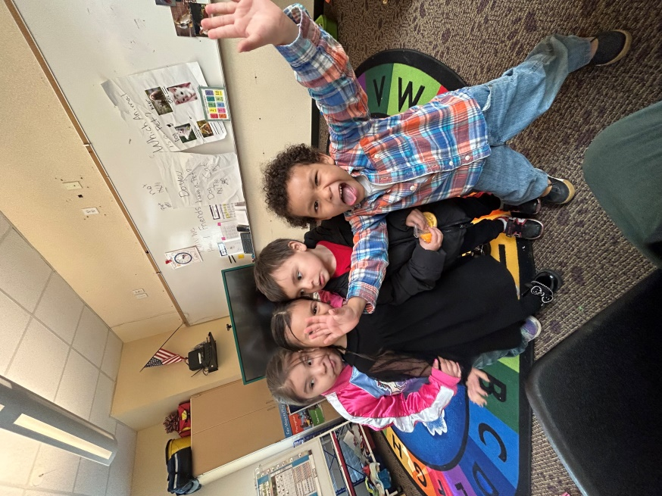
We support your right to the privacy of your family’s confidential information. We will not retaliate in any way if you choose to file a complaint with us, with the United States Department of Education or the United States Department of Health and Human Services.
Contact Person: Program Manager (509) 634-2760
We reserve the right to change the terms of this notice and will inform you by mail of any changes. This notice was published and becomes effective on August 17, 2015.
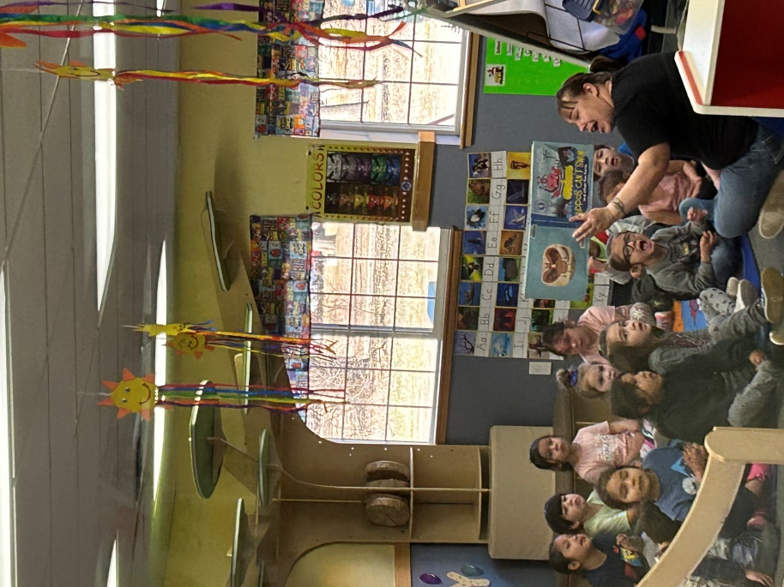

Custody Orders and/or Court Related Requests
The Office of Reservation Attorney will be consulted when any child or family enters the program with Custody Orders, Restraining Orders, Court ordered parenting plans, or any other court orders that directly affect the health/safety and/or education of any child in the program.
Head Start centers will not serve in any capacity as a mediator, consultant, and/or supervised visitation location for any family involved in legal matters.
Head Start staff will not write letters of support, character reference, and/or any other type of letter for families in regards to any court proceeding. Head Start staff who receive any subpoena to court will consult with the Office of Reservation Attorney and request to not be involved in any legal matters brought before any court of any Head Start child(ren) or families.

Program Involvement of Registered Sex Offenders
In accordance with Washington State Senate Bill 6675 which allows an owner or employee of a public or private entity that's primary purpose is education, recreation or care of a child to prohibit a sex offender from their premises via written notification. CCT HS prohibits Tier I, Tier II, and Tier III registered sexual offenders from being on school property. However, Tier I registered sex offenders who have not committed an offense in the last 5 years, provide updated court documentation, and with the written permission of the CCT HS policy council or Colville Business Council (CBC), may have the option to pick up their child(ren) from the centers or attend mandated school meetings such as parent/teacher conferences, family nights, or parent orientation by making prior arrangements with the Family Support Specialist (FSS).

Intoxicated Caretaker Policy
Health and safety are two main issues concerning our children. As adults and caretakers, it is our responsibility to ensure that the health and safety needs of our children are being met. Children left in the care of an intoxicated caretaker are at risk for abuse and neglect, due to inadequate supervision as a result of the effect that the substance has on the disposition of the caretaker.
No child will be allowed to leave the bus if the primary caretaker(s) appear to be intoxicated. It is the responsibility of the bus monitor and bus driver to assure that a child is not left in the care of an intoxicated caretaker.
If the caretaker appears to be intoxicated:
- Step 1: The child will be returned to the Head Start center. And
- Step 2: The Teacher will contact the Child’s parent/guardian; explain the situation and identify where the parent/guardian would like the child to go. (Unless the intoxicated caretaker is the parent/guardian then refer to Step 3)
- Step 3: If the Head Start teacher is unable to contact the parents, they will contact the Child’s emergency contact person. (Located in the Child’s Head Start file)
- Step 4: If no responsible adult can be located, a referral will be made to the appropriate Child Protective Service Agency.
A referral will also be made to the Family Support Specialist, who will then make a home visit. If the Family Support Specialist is unavailable, a referral will be made to the Site Supervisor. A written report will be submitted to the Head Start Program Director, and a copy of the report will be placed in the child’s file.
If the caretaker is intoxicated on more than one occasion, a referral will be made to the appropriate Child Protective Service Agency.

Reporting of Suspected Child Abuse and Neglect
Reporting Procedure: Since all children have the right to a psychologically and physically safe environment, it is, therefore, the responsibility of the Colville Tribes Head Start Staff to report any violations of the standard of care, among co-workers or other adults, immediately to their supervisor. The supervisor must act in a timely manner to reconcile the incident.
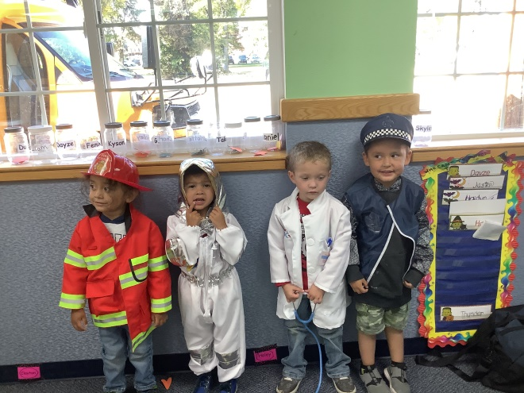
How is Abuse Reported?
Any person suspecting child abuse needs to immediately make a report to their local law enforcement agency or local child protective service agency. A REPORT OF SUSPECTED ABUSE IS ONLY A REQUEST FOR AN INVESTIGATION. The person making the report does not need to prove the abuse. Investigation and validation of child abuse reports are the responsibilities of Law Enforcement and Child Protective Services.
Head Start staff will support families who are involved with the DCYF and/of Tribal Child and Family Services program and will preserve absolute confidentiality of all records pertaining to a report in accordance with state law.

Mandated Reporters
HEAD START EMPLOYEES ARE MANDATED BY LAW TO REPORT ANY SUSPECTED ABUSE OR NEGLECT IMMEDIATLEY. ACCORDING TO 18 USC 1169: FAILURE TO REPORT ABUSE; Any person, who fails to immediately report such abuse or actions, shall be fined not more than $5,000 or imprisoned for not more than SIX months or both.

Tobacco Use
Second-hand smoke has been recognized as a health hazard and a trigger for asthma. For this reason, use of tobacco products (smoking, smokeless tobacco, chewing tobacco) is strictly prohibited in all buildings and grounds occupied by the Colville Tribal Head Start program, and at Head Start sponsored events off the Head Start premises. Tobacco-related clothing, gear or paraphernalia, tobacco-related advertising and marketing are strictly prohibited.

Grievance
Dear Parents:
The Early Childhood Parent and Community Concern/Complaint/Grievance Procedure are established to promote open and clear communication between parent/community members and the Early Childhood Education/Head Start staff.
The program recognizes that parents are the “first” and “primary” educators of their children and the staff plays a secondary role with this process.
We recognize that to have a program where parents feel free to participate as advocates for their child, there must be options available when the method of communication breaks down and parent /community rights are violated.
Parents are always welcome to visit the Head Start centers, make requests for assistance, and expect results in a timely manner. Parents are always invited to visit the Head Start Classrooms at any time. Parents may make a request to speak with the teacher about their child’s progress, or any problems or concerns they may be having. (Please be aware that due to child supervision and the daily classroom schedule, the teacher may not be immediately available at that moment and time). Parents are encouraged to visit the Early Childhood Office and to seek out the Family Service Specialists in each district. All Early Childhood Staff are here to assist you in any way that we can!
We recognize that without community involvement and participation our program would not be able to provide the best quality services to our children and families. We also recognize that many of our past parents are members of the community at large whom we rely on to assist us with our program goals and services.
At times, parent/community members may feel unhappy or unsatisfied with the decisions, actions or behaviors of the staff. If this is the case, any parent/community member is encouraged to file a concern/complaint form. The grievance procedure is designed for this purpose, to air the concern, complaint or grievance and expect a timely response and to have a process for appealing if the response is not satisfactory to a parent or community member.
Parents/community members shall not be discriminated against for filing a concern/complaint/ grievance. As Parent/community members you have the right to advocate for your child and for yourself.
CONCERN Is a minor action by staff which requires more than discussion by parent/ community members. It is an action that may have happened before or was addressed before, and the request/concern was ignored by staff or program personnel.
COMPLAINT The action is severe enough and the incident has occurred enough to warrant a complaint against the staff member or program involved. This may also be a situation that is an emergency and demands immediate action.
GRIEVANCE The process which allows for parent’s/community members who filed a concern or complaint, and it was not resolved to their satisfaction so must utilize the procedure to appeal to a higher authority for resolution. A concern, complaint or grievance may all be filed in the same manner and will be handled with the same procedure; however, the difference may be the duration of time, response and decision by the appropriate Early Childhood personnel and Head Start Policy Council.
PARENT/COMMUNITY CONCERNS/COMPLAINTS/GRIEVANCE PROCEDURE Colville Tribal Head Start makes every effort to resolve differences of opinion that may occur between the program and enrolled families or citizens of the community. A grievance is a written statement that the laws, rules, policies or procedures under which the Head Start program operates may have been violated. Head Start parent concerns should be discussed with the staff person most directly involved with the concern. If no resolution is reached, the concern may be taken to the Site Supervisor.
Step 1. A concern, complaint or grievance must be presented in written format to the Site Supervisor. A form is available to fill out for this process at all our Head Start centers and the Early Childhood Office. You may have the Family Support Specialist assist you if needed. (Unless the concern/complaint/grievance is about the FSS, then you may ask another staff member to assist you) Once completed the form or written complaint should be sealed in an envelope and forwarded to the Site Supervisor for the district in which the complaint exists. The complaint will be stamped with the date received by the Site Supervisor once it is received.
Step 2. The Site Supervisor shall within five (5) working days of receiving the concern/complaint, review the complaint, interview appropriate parties involved, gather necessary documentation, and meet with parents and other relevant parties. If the complaint is of an emergent concern, the Site Supervisor will act immediately. Once a resolution is determined for the concern/complaint by the parent/community member and Site Supervisor, it will be written and signed by both parties.
Step 3. If the procedure in STEP 2 does not resolve the concern or complaint the parent/community member may request to have the information or paperwork regarding the complaint forwarded to the Early Childhood Education Program Manager. The Program Manager will have five (5) working days to review the information, gather new data if needed and contact the parent for a meeting. Once the Program Manager and parent/community member meet, if there is a resolution to the complaint, it will be written and signed by both parties.
Step 4. If STEP 3 does not resolve the complaint, the parent may request to have their grievance heard at the next Policy Council Meeting. If the concern is of an emergent nature which demands immediate action the Policy Council Chairperson shall schedule a special meeting. The Program Manager will forward the Concern/complaint and other paperwork to the Policy Council Chairperson. Upon receipt of the file, the Policy Council Chairperson shall review, gather additional information if needed, schedule a hearing, and notify the parent/community member who has lodged the grievance of the hearing date. During the hearing, the following steps will be followed:
Parent/Community member filing grievance will present their information.
Policy Council Member(s) will review information, interview parties involved if needed.
Policy Council will render a decision on the grievance, put in writing and forward to the parent/guardian within three, (3) days of the decision.
The decision of the Policy Council will be final.
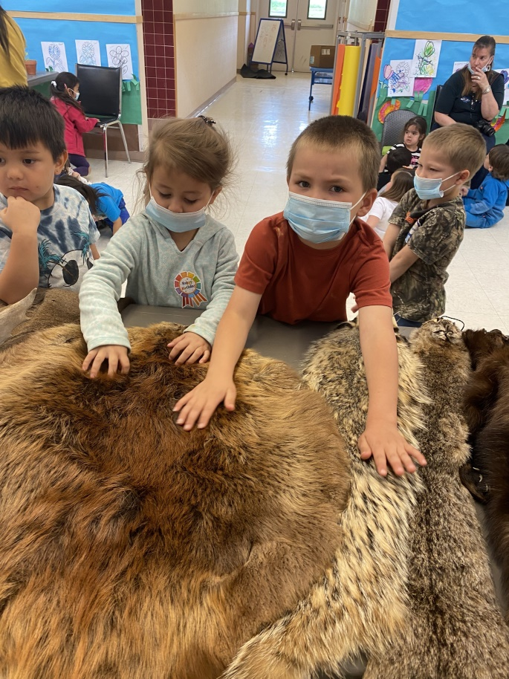

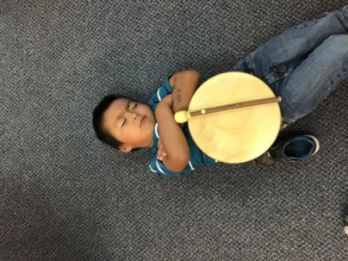

GRIEVANCE FORM

Date: _________________________

Grievant Name: ___________________________ Phone Number: ______________________
Grievant Address: _____________________________________________________________
Description of the Problem: __________________________________________________________________________________________________________________________________________________________________________________________________________________
Date of the incident or concern: ________________
Description of what has already been done to resolve the concern or complaint: ________________________________________________________________________________________________________________________________________________________________________________________________________________________________________________________________________________________
How the grievant would like to see the problem resolved: __________________________________________________________________________________________________________________________________________________________________________________________________________________________________________________________________
Grievant Signature: ______________________________________

Assistance can be provided in preparing this written grievance if requested

