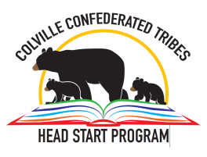 Colville Tribes Head Start
PERMISSION FOR RELEASE OR OBTAIN INFORMATION

I, hereby, provide the Colville Tribes Head Start consent to obtain and/or share medical/educational/media information with the following agencies in regards to my child: _________________ DOB: _________.
In granting such permission, I understand that such information will remain confidential and will be used for the benefit of my child. This consent is valid through the child’s enrollment with Head Start.

Please check (√) that which applies.
_____ Physician/Clinic: (_______________________________)
_____ Dentist/Clinic: (_________________________________)
_____ Smile Mobile
_____ Kindergarten Transition. Transitioning School name(s): (_____________________)
_____ Indian Health Services
_____ Home Visiting Program
_____ Early Learning center-IFSP: (__________)
_____ Local School District-IEP (specify: __________________)
_____ Tribal Health [CHN, CHR, WIC, Nutritionist/Dietician, Diabetes Program]
_____ TANF (Individual Development Plan)
_____ Tribal Enrollment (Certificate of Enrollment & Birth Certificate)
_____ Behavioral Health/Alcohol Program
_____ CPS/CFS/Family Preservation
_____ Energy Assistance (LIHEAP, other___________)
_____ Parent Committee
_____ Tribal Child Care
_____ Child Profile/State Immunization data system
_____ OTHER:_____________________________________

I, hereby, release the Colville Tribes Head Start and its staff from any legal liability for providing above information. While the child is enrolled with the program, I fully understand that I have the right to review records maintained on my family and to dispute or correct any information I feel is incorrect.

________________________________________ ________________
Parent/Guardian Signature Date

________________________________________ ________________
Parent/Guardian Signature Date

